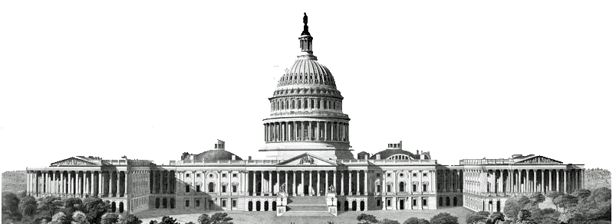
AH1-Unit 2-3 Understanding the U.S. Constitution Name ______________________________
Preamble

ARTICLE I

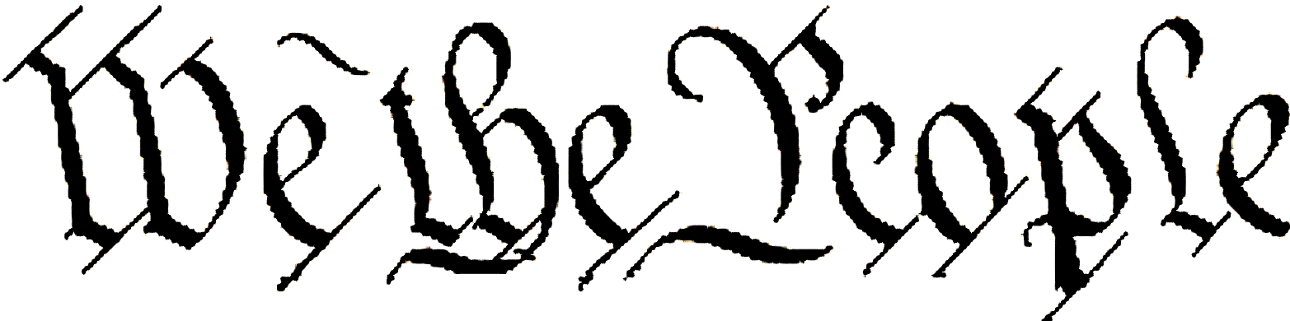

The Constitution is the most important guide to all parts of the U.S. government and serves as the “supreme law of the land.” This means that no state, no branch of government, no person, no elected official—not even the president or Congress—can contradict the Constitution’s expressed powers or protection of the rights and freedoms of American citizens.
The Constitution is made up of 3 parts: the preamble, the 7 articles, and
27 amendments. The Constitution sets up a federal system of government which means power is shared between the national government and state governments. Articles I, II, and III separate the power of the national government into 3 branches: legislative, executive, and judicial. The legislative branch (Congress) makes the laws; the executive branch (the president and the federal bureaucracy) carries out the laws made by Congress; and the judicial branch (the Supreme Court and other federal courts) settle any disagreements that arise from the Constitution. Other articles tell how to change and approve the Constitution and how states will work with each other and the national government.

- The Preamble begins with the phrase “We the people of the United States...” What message were the Founding Fathers trying to send by including this phrase in the Constitution?
- The Preamble continues with “…in Order to form a more perfect Union…” Compared to the Articles of Confederation, what were the Founding Fathers hoping to accomplish?
- The Preamble then lists five goals of the new government. Which of these five goals do you think is most important for a government to achieve?

LEGISLATIVE BRANCH (Congress)

- (a) Who are legislative (law-making) powers granted to? (b) What two bodies make up Congress? 1.1
- (a) How long is the term for a Representative? 1.2.1 (b) For a Senator? 1.3.1
- (a) How old must a Representative be to be elected? 1..2.2 (b) For a Senator? 1.3.3
- (a) Which house has the power of impeachment (to accuse an elected official of a “high crime or misdemeanor”)? 1.3.6 (b) Which house has the power hold a trial and remove an impeached official from office? 1.3.6
- Which house has the power to propose a law concerning taxes (raising revenue)? 1.7.1
- What can the legislative branch do if the President vetoes a bill? 1.7.3
- In Section 8, the Constitution lists 18 enumerate powers (also known as delegated or expressed powers) of Congress. Which 3 are most important? 1.8
- Which of the 18 powers gives Congress the most flexibility to adapt to unforeseen future changes? 1.8.18
ARTICLE II
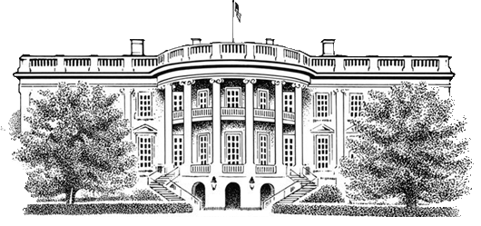

eXECUTIVE BRANCH (presdient and bureaucracy)

- How many years does a president serve? 2.1.1
- (a) How old does someone have to be to be elected president? 2.1.5
(b) What other qualifications must a person meet to be elected president? 2.1.5
- What role does the president play in the U.S. military? 2.2.1
- (a) What role does the president play in making treaties with nations? 2.2.2
(b) Who must approve treaties with foreign countries? 2.2.2
- (a) How are ambassadors and Supreme Court judges chosen? 2.2.2
(b) Who must approve ambassadors and judges that have been appointed? 2.2.2
- Under what conditions can a president be removed from office? 2.4
ARTICLEs IV, V, VI, VII

- In Article IV, which branch of gov’t has the power to admit new states into the Union? 4.3.1
- In Article V, how are new Constitutional amendments proposed? 5
ARTICLE III
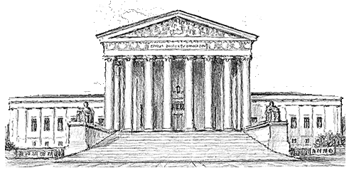

JUDICAL BRANCH (Supreme Court and federal courts)

- When the Judicial Branch was created, the only federal court it created was the Supreme Court. According to the Constitution, which branch of government can create lower federal courts? 3.1
- The term of office for a Supreme Court justice is “during good behavior.” How long is that term? 3.1
- (a) What role does the Supreme Court play in treaties with other nations? 3.2.1
(b) What role does the Court play involving disputes between states? 3.2.1
- What responsibility does Article III, Section 3 require the courts to oversee? 3.3

- What phrase in section 2 of Article VI gives this part of the Constitution the name “Supremacy Clause”? 6.2
- In Article VII, how many states were needed to ratify the Constitution? 7

