AH1H-Unit 6

Birth of the Republican Party Handbill Assignment

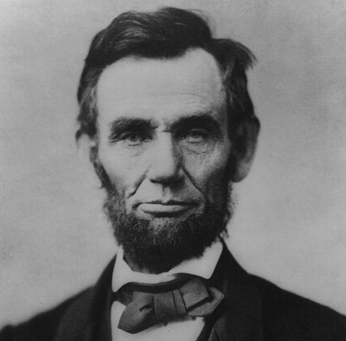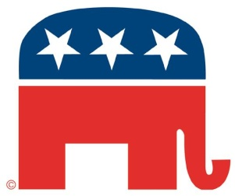
During the Antebellum Period, handbills were used during political campaigns to advertise for candidates and publicize party platform positions. Today, you will create Handbills for each of the following political parties
(so that means FIVE TOTAL HANDBILLS…please staple them all together):

- Know-Nothings (American Party)
- Whig Party
- Democratic Party
- Free Soil Party
- Republican Party

Your handbills must include:
- The name of the political party
- A statement of key platform issues
- Names of prominent members from the 1850s to 1860 (there may be some overlap because some of these parties merged and/or split during this time period)
- An appropriate party slogan
- A COLOR illustration that helps convey the message of the party & would serve to draw in potential voters

You should read all of the sources listed below and you are required to pull information from ALL of the sources (cite the source on your handbill):
- McPherson-Know Nothings-Rise of Republican Party reading (find it on my website),
- article on Free-Soil Party (on my website)
- article on Know-Nothing Party (on my website),
- Ch. 10, Section 3 of your text book (p. 318-321)

You can find 2 examples of historic handbills on the back of this assignment. While the examples don’t match the exact specifications of this assignment, they should give you a model of the proper handbill style. Also check out great examples I have from previous classes to get an idea of what I’m looking for.

