Essay Reference Tables for DBQ
HIPP-O
Analyzing Primary Source Documents & incorporating them into your DBQ essay
H | Historical Context  The [name of doc] from [time/place/author] relates to the [era] because… (Document A) or  The [name of doc] was created in [year] when [context- what was going on?] (Document A).
I | Intended Audience  The intended audience of [name of doc, written by/created by] was [state audience]. It was intended to [intent]. (Document A)
P | Purpose  (Persuade, compliment, discredit, disagree, warn, encourage, promote, urge, apologize, question, outrage, solicit, clarify, demand, outline, hint, oppose, inspire, expose, intensify, reflect, argue, assert, compromise, connect, illustrate, introduce, offer, predict, suggest, compliment, establish, justify, qualify, distinguish, propose, honor, contrast, question)  The purpose/intent for [name of doc] was to [why was the doc created]. [Name of doc] was created/written at that time to/because [why doc was written. (Document A)
P | Point-of-View  (Who, explain the influence, main idea)  The point of view/perspective of [creator] was that of a [describe type of person] during the [era/time pd./ situation]. (Document A)
O | Organization/ use in argument (sO what?)  Use this to seamlessly incorporate your doc into the text of the essay every single time.

Incorporating doc analysis (HIPP) into your essay:
*Always lead up to your doc- don’t just randomly shove it in there.
*If you mention a person/speaker/author when referring to a document’s author or subject, you MUST discuss who that person is!
- Answer the question- lead up to the doc, establish context.
- HIPP analysis
- O- relevance- This reveals that…. Therefore……

*At least 3 pieces of significant outside information- Names, dates, legislation, reforms, events

Format of DBQ essay:
I. Intro
a. Historical Context/ Contextualization (2-4 sentences establishing the time period- lead up to the thesis statement)
b. Thesis statement

II. Body paragraphs
a. Topic sentence
b. Supporting information- doc analysis & outside info
c. Summary sentence- analysis- link it back to the Q with the “why”

III. Synthesis (extend or modify the statement; provide counter argument; link to a larger historical time pd, geogr area, context or event; significantly references additional primary or secondary sources)

- Conclusion

Historical Thinking Skills/ Types of Essay Questions
What type of question is it?
I. Chronological Reasoning | Historical Causation  How and why did something happen? | This led to… Immediately causing…; A proximate cause of…; The deep-rooted causes…; …which spurred…; Underneath it all was…; A change took place between… and … because…; The underlying causes of… had been…; If it were not for…; Consequently, …; The main/only reason… happened is because…; This stemmed from…; This sparked…
 | Continuity and Change over Time  What is similar and what is different over time? | Dating back to…; As seen as far back as…; Though it evolved into…, it still…; One thing that remained constant was…; …still persisted in the form of…; Eventually…; Over time…; This all changed when…
 | Periodization  What time period/era does this fit in to? Turning points. | The real turning point of… was…; …can be considered the beginning/end of…; …can be classified in the …era because…; The …era/period was one of …; The true beginning of… was…; …was a time of….; … and … serve as the bookends of the period because…
II. Comparison & Contextualization | Comparison  What are the similarities and differences? | Similarly, …; Likewise…; In a similar way,…; Much like…; … can be grouped with…; … shares a common … with …; … would agree/disagree with…;  Although…; Even though…; Despite…; In contrast,…; Contrary to…; On the other hand,…’ To a lesser extent,…;
 | Contextualization  Why did it matter/happen at that given time in history? | ONLY IN DBQ  This makes sense because nationally/internationally at the time…; The theme of … is seen…; … was a time of… because…; … serves as a great example of…; The larger story of…; This fits into…; … is representative of…; … exemplifies the larger/emerging trend of…
III. In all DBQs- Synthesis | Synthesis  So what? Why does it matter? | Another region where we see the theme of … is …; The people of the … also faced a similar problem of…; While… was a major cause of… another major influence was …; An additional way…; While… was occurring, others were…; Despite…., it can also be argued…

DBQ Checklist | Did you?
Thesis (1 point) | State a thesis that directly answers all parts of the question and does more than just restate the question?
Analysis of Documents  (3 points)  HIPP + link the doc to your argument/thesis- what is the relevance?? | Doc 1- H. Cont./ Intended Aud/ Purp/ POV & relevance to the Q/th stmt
 | Doc 2- H. Cont./ Intended Aud/ Purp/ POV & relevance to the Q/th stmt
 | Doc 3 H. Cont./ Intended Aud/ Purp/ POV & relevance to the Q/th stmt
 | Doc 4 H. Cont./ Intended Aud/ Purp/ POV & relevance to the Q/th stmt
 | Doc 5 H. Cont./ Intended Aud/ Purp/ POV & relevance to the Q/th stmt
 | Doc 6 H. Cont./ Intended Aud/ Purp/ POV & relevance to the Q/th stmt
 | Doc 7 H. Cont./ Intended Aud/ Purp/ POV & relevance to the Q/th stmt
Outside Information (1 point) | Offer plausible analysis of historical examples beyond the documents to support the thesis and your argument- 3 pieces of outside info.?
Contextualization  (1 point)  (1st part of intro) | Accurately and explicitly work the essay into the larger story of the United States within this time period?
Synthesis (1 point)  (a separate paragr before the concl.) | Appropriately extend or modify the stated thesis or argument? OR | Recognize and effectively account for disparate sometimes contradictory evidence from primary sources and/or secondary sources in crafting a coherent argument? OR | Appropriately connects the topic of the question to other historical periods, geographic areas, contexts or circumstances.
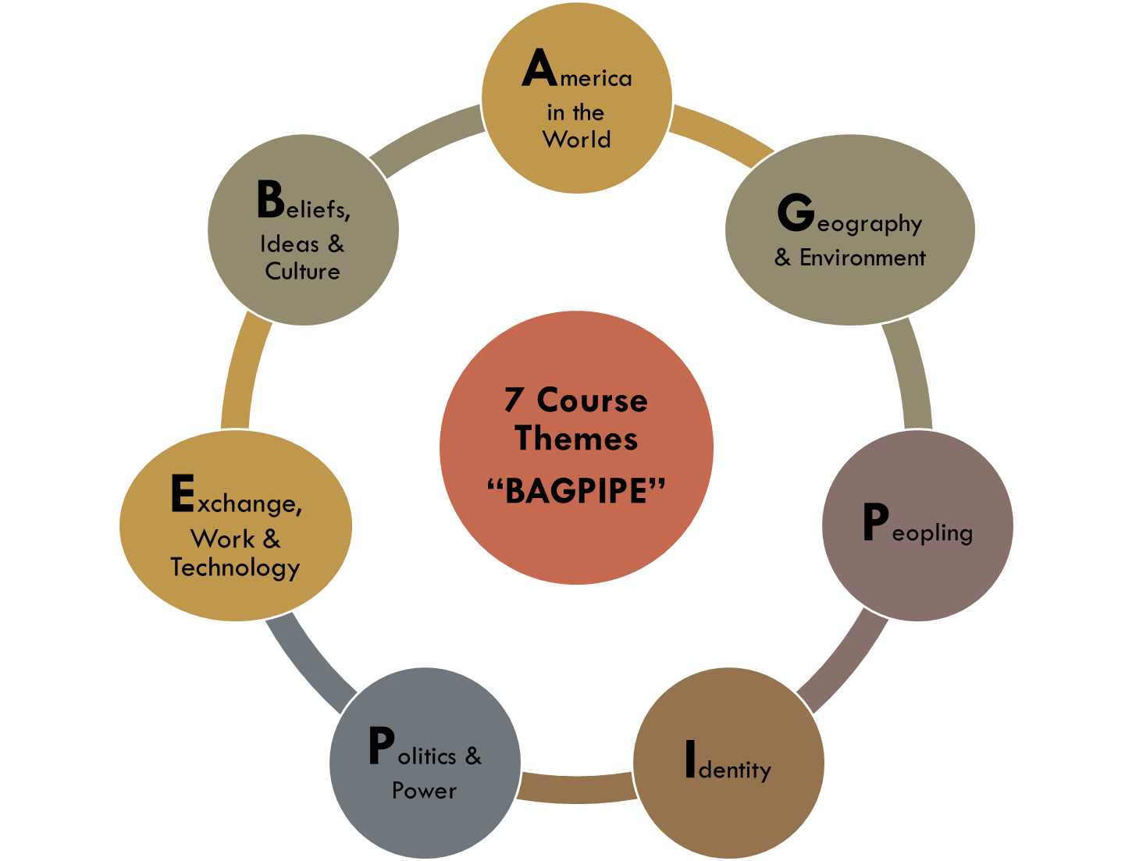
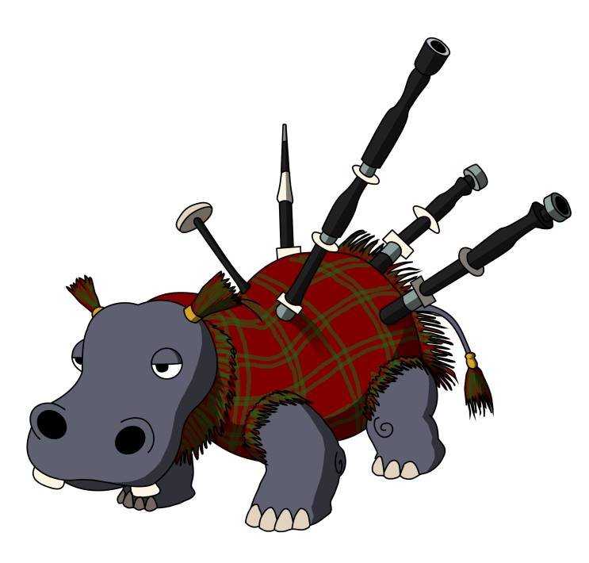
Consider using these as your categories

