How a stab wound, a gashed nose and a pierced ear helped scientists identify a 400-year-old head as the skull of France's King Henri IV
By Ian Sparks
Last updated at 11:24 AM on 16th December 2010
Scientists believe they have identified a mummified head as belonging to France's King Henri IV who was assassinated in 1610 at the age of 57.
After nine months of tests, researchers say they have positively identified the monarch's embalmed head which was shuffled between private collections ever since it disappeared during the French Revolution in 1793.
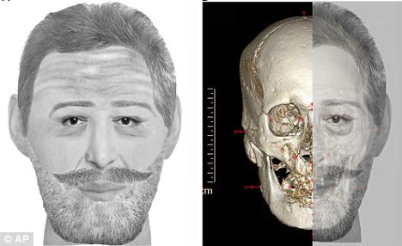
The digital image (left) shows a reconstruction of King Henri IV's face alongside with his mummified skull which was hacked off his body by French revolutionaries
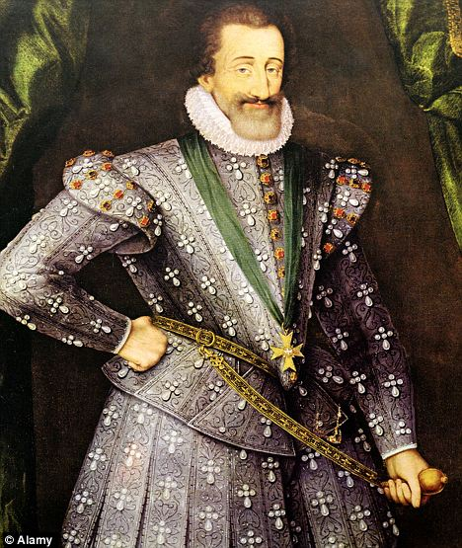
Known as the 'green galant', the king had legions of female admirers. He also promoted religious tolerance and was credited with brokering peace between Catholics and Protestants
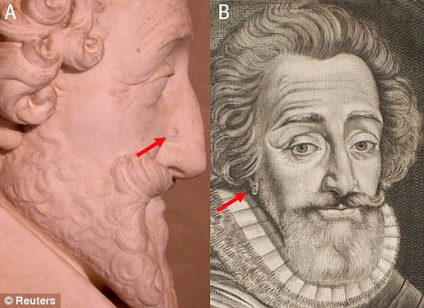
This two-way combo shows (left) a statue of the king showing the cut to his nose and (right) and an engraving of the king wearing an earring in the right ear lobe. It was these markings on the skull which helped scientists identify it as belonging to the king
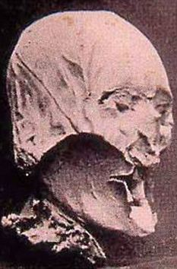
The head disappeared but resurfaced in 1919 when an antiques dealer bought it from an auction house for three francs. Ever since then it was kept in secretive private collections
Henry IV was assassinated by a Catholic fanatic as his coach became caught up in traffic congestion 400 years ago.
He was buried in the Basilica of Saint Denis near Paris, but during the frenzy of the French Revolution, the royal graves were dug up and revolutionaries chopped off Henry's head, which was then snatched.
The head disappeared but resurfaced in 1919 when an antiques dealer bought it from an auction house for three francs. Ever since then it was kept in secretive private collections.
In their examinations of the monarch's head, they found features often seen in the king's portraits, including a dark wound above his right nostril.
They also found a healed bone fracture above his upper left jaw, which matched a stab wound the king suffered during an assassination attempt in 1594 and a pierced ear.
Philippe Charlier, a forensic medical examiner at Poincare University Hospital in Garches, France, led the 19-strong team who ran numerous forensic tests.
He said: 'This case was considered with the same (level of severity) as if it were a recent forensic case.'

POPULAR KING WHO PROMOTED RELIGIOUS TOLERANCE AND HAD LEGIONS OF ADMIRERS
Known as the 'Green Gallant', King Henri IV was one of France's most popular monarchs and is said to have had legions of female admirers.
He promoted religious tolerance and was credited with brokering peace between Catholics and Protestants.

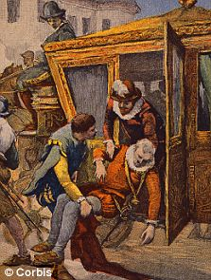
To facilitate this, he converted from Calvinism to became a Catholic, declaring 'Paris is worth a Mass' before becoming king. In doing so he re-established a Catholic on the throne and satisfied the wishes of the vast majority of the population. He also enshrined religious freedom for Protestants with the Edict of Nantes.
He was assassinated (pictured above) by a Catholic fanatic when his coach became stuck in traffic.
Henri showed great care for his subjects while also centralising royal power.
His rule brought a period of social stability and he is credited with kick-starting the French economy.
He also built various Parisian landmarks including the Pont Neuf bridge and the Place des Vosges. He was the first of the Bourbon line of monarchs, which included his grandson Louis XIV, the Sun King.
The results of the research identifying the king's head were published today in the BMJ medical journal.
He said: 'The preservation was excellent, with all soft tissues and internal organs well conserved.
'We used the latest forensic techniques to identify features seen in portraits of the king. The head had a light brown colour, open mouth and partially closed eyes.
'The methods used to embalm the head also matched techniques in use at the time of his death.'
Charlier and colleagues compared the embalmed head to an autopsy report describing the particular embalming process used for French kings, written by the king's surgeon.
Perfumers on the team used their professionally trained noses to identify specific embalming substances in the mouth used to hide nasty smells.
'It was not possible to use DNA evidence to identify the head because it was impossible to find a sample from it that could be guaranteed to be uncontaminated,' he added.
But radiocarbon-dating yielded a date range of between 1450 and 1650, which fitted with the king's own lifespan from 1553 to 1610, he said.
Professor Charlier has been dubbed the 'Indiana Jones of the graveyards' after previous finding that the supposed bones of Saint Joan of Arc actually came from an Egyptian mummy and a cat.
He also determined that a mummified heart held in the Saint-Denis crypt came from the uncrowned boy king Louis XVII, who died in prison during the Revolution.
And he confirmed that Napoleon died of stomach cancer, scotching the myth the emperor had been poisoned by his British captors.
The French researchers also created a digital facial reconstruction and ran computer tomography scans which showed the skull was consistent with all known portraits of Henry IV and the plaster mould made of his face just after his death.
Frank Ruehli, of the University of Zurich who didn't work on the project said the research was credible but that it would been more persuasive if the French scientists had found DNA evidence.
'They've narrowed it down considerably and it probably is Henry IV,' he said. 'But without the final DNA proof it is hard to say absolutely who it is.'
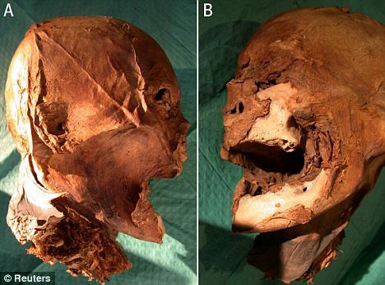
The mummified skull of King Henri IV. Radiocarbon-dating yielded a date range of between 1450 and 1650, which fitted with the king's own lifespan from 1553 to 1610
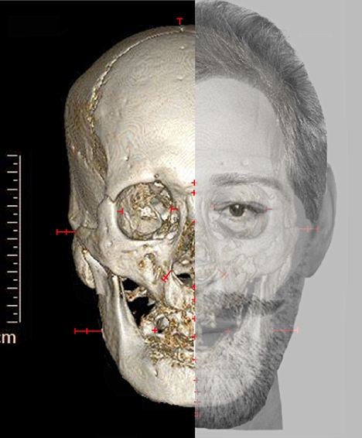
The rresearchers also created a digital facial reconstruction and ran computer tomography scans which showed the skull was consistent with all known portraits of Henry IV and the plaster mould made of his face just after his death
Still, Ruehli said the French scientists did the next best thing, by matching evidence of Henry IV's facial lesion and healed wounds to historical documentation of those traits, which were likely unique to the monarch.
The discovery comes at the end of King Henry IV year in France, which marks 400 years since the monarch was murdered.
Next year, France will hold a national Mass and funeral for Henry IV. His head will then be reburied alongside the rest of the country's former kings and queens, in the Basilica of Saint Denis.
http://www.dailymail.co.uk/news/article-1338777/French-kings-lost-head-Mummified-400-year-old-head-Frances-King-Henri-IV.html#

