In Praise of Slums

Why millions of people choose to live in urban squalor.

BY CHARLES KENNY | SEPT/OCT 2012
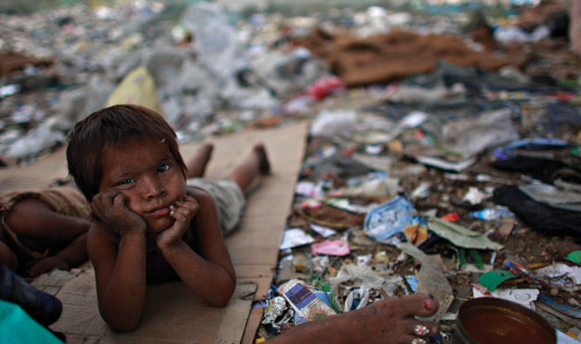
There is something viscerally repulsive about urban poverty: the stench of open sewers, the choking smoke of smoldering trash heaps, the pools of fetid drinking water filmed with the rainbow color of chemical spills. It makes poverty in the countryside seem almost Arcadian by comparison. The rural poor may lack nutrition, health care, education, and infrastructure; still, they do the backbreaking work of tending farms in settings that not only are more bucolic, but also represent the condition of most of humanity for most of history. With life so squalid in urban slums, why would anyone want to move there?
Because slums are better than the alternative. Most people who've experienced both rural and urban poverty choose to stay in slums rather than move back to the countryside. That includes hundreds of millions of people in the developing world over the past few decades -- and 130 million migrant workers in China alone. They follow a well-trodden path of seeking a better life in the bright lights of the city -- think of Dick Whittington, the 14th-century rural migrant who ended up lord mayor of London. The good news is that the odds of living that better life are better than ever. For all the real horrors of slum existence today, it still usually beats staying in a village.
Start with the simple reason that most people leave the countryside: money. Moving to cities makes economic sense -- rich countries are urbanized countries, and rich people are predominantly town and city dwellers. Just 600 cities worldwide account for 60 percent of global economic output, according to the McKinsey Global Institute. Slum dwellers may be at the bottom of the urban heap, but most are better off than their rural counterparts. Although about half the world's population is urban, only a quarter of those living on less than a dollar a day live in urban areas. In Brazil, for example, where the word "poor" conjures images of both Rio's vertiginous favelas and indigenous Amazonian tribes living in rural privation, only 5 percent of the urban population is classified as extremely poor, compared with 25 percent of those living in rural areas.
But is it much of a life, eking out an existence in today's urban squalor? Our image of modern slums comes from films like Slumdog Millionaire and books like Katherine Boo's Behind the Beautiful Forevers, portraits of India's urban underclass not all that far removed from the horrifying picture of 19th-century industrialization in Charles Dickens's novels about the misery and violence of London's slum dwellers. A recent opinion article in the New England Journal of Medicine called urbanization "an emerging humanitarian disaster." And urban theorist Mike Davis writes in Planet of Slums, "[N]o one knows whether such gigantic concentrations of poverty are biologically or ecologically sustainable."
But slum living today, for all its failings, is markedly better than it was in Dickens's time.
For one thing, urban quality of life now involves a lot more actual living. Through most of history, death rates in cities were so high that urban areas only maintained population levels through constant migration from the countryside. In Dickensian Manchester, for instance, the average life expectancy was just 25 years, compared to 45 years in rural Surrey. Across the world today, thanks to vaccines and underground sewage systems, average life expectancies in big cities are considerably higher than those in the countryside; in sub-Saharan Africa, cities with a population over 1 million have had infant mortality rates one-third lower than those in rural areas. In fact, most of today's urban population growth comes not from waves of villagers moving to the city, but city folks having kids and living longer.
In part, better quality of life is because of better access to services. Data from surveys across the developing world suggest that poor households in urban areas are more than twice as likely to have piped water as those in rural areas, and they're nearly four times more likely to have a flush toilet. In India, very poor urban women are about as likely to get prenatal care as the non-poor in rural areas. And in 70 percent of countries surveyed by MIT economists Abhijit Banerjee and Esther Duflo, school enrollment for girls ages 7 to 12 is higher among the urban poor than the rural poor.
That said, modern slum dwellers -- about one-third of the urban population in developing countries -- are some of the least likely to get vaccines or be connected to sewage systems. That means ill health in informal settlements is far more widespread than city averages would suggest. In the slums of Nairobi, for example, child mortality rates are more than twice the city average and higher, in fact, than mortality rates in Kenya's rural areas.
But Nairobi's slums are atypically awful, more an indicator of the Kenyan government's dysfunction than anything else. In most developing countries, even the poorest city dwellers do better than the average villager. Banerjee and Duflo found that, among people living on less than a dollar a day, infant mortality rates in urban areas were lower than rural rates in two-thirds of the countries for which they had data. In India, the death rate for babies in the first month of life is nearly one-quarter lower in urban areas than in rural villages. So significant is the difference in outcomes that population researcher Martin Brockerhoff concludes that "millions of children's lives may have been saved" in the 1980s alone as the result of mothers worldwide moving to urban areas.
Slum life remains grim. HIV prevalence rates are twice as high in urban areas of Zambia as they are in rural areas, for instance, and the story is worse with typhoid in Kenya. Slum residents are also at far greater risk from violence, outdoor air pollution, and traffic accidents than their rural counterparts. And the closer conditions in slum areas get to a state of anarchy mixed with kleptocracy, the more health and welfare outcomes tend to resemble those of Dickensian Manchester.
But all things considered, slum growth is a force for good. It could be an even stronger driver of development if leaders stopped treating slums as a problem to be cleared and started treating them as a population to be serviced, providing access to reliable land titles, security, paved roads, water and sewer lines, schools, and clinics. As Harvard University economist Edward Glaeser puts it, slums don't make people poor -- they attract poor people who want to be rich. So let's help them help themselves.
http://www.foreignpolicy.com/articles/2012/08/13/in_praise_of_slums?page=full

