Honors US History: Unit 5

Political Machines
As cities and their problems grew rapidly the political environment changed. No longer did politicians run small manageable cities. These were big cities with big city problems and the government structures designed to cope with these problems grew. As the government grew it became the livelihood for many professional politicians. Some would argue that these politicians were corrupt. They would argue that they provided a needed service.
Political Machines were organizations that provided social services and jobs in exchange for votes.
The machines were run by a boss who in turn had precinct captains, ward captains and district captains underneath him. All of them made sure that the poor had what they needed. They also made sure the poor voted... for them!
The following selection illustrates the way the politicians of the city recruited followers:
What tells in holdin your grip on your district is to go right down among the poor families and help them. I've got a regular system for this. If there's a fire in Ninth or Tenth or Eleventh Avenue, for example, any hour of the day or night, I'm usually there with some of my election district captains as soon as the fire engines. If a family is burned out I don't ask them if they are Republicans or Democrats, and I don't refer them to the Charity Organization Society, which would investigate their case in a month or two and decide if they are worthy of help about the time they are dead from starvation. I just get quarters for them, buy clothes for them if their clothes were all burned up, and fix them up until they get things runnin' again. It's philanthropy, but it's politics too - mighty good politics. Who can tell me how many votes one of those fires brings me? The poor are the most grateful people in the world, and, let me tell you, they have more friends in their neighborhoods than the rich have in theirs...
Another thing, I can always get a deserving man a job. I make it a point to keep track of jobs, and it seldom happens that I don't have a few up my sleeve ready for use.
I hear a young feller that's proud of his voice... I ask him to join our Glee Club. He comes up and sings, and he's a follower of Plunkitt for life. Another young feller gains a reputation as a baseball player in a vacant lot. I bring him into our baseball club. That fixes him. You'll find him working for my ticket at the polls next election. I rope them all in by givin' them opportunities to show off themselves off. I don't trouble them with political arguments.
--George Washington Plunkitt, Politician, New York, 1889
Machine Organization
The political machine consisted of three elements: party bosses or a county committee, which governed the party machine and controlled the politicians; election district captains who mobilized and organized support at the neighborhood level; and party loyalists who supported the machine with votes and financial support in return for jobs, favors and help provided by bosses and election district captains.
In some cases, a single leader, called the "party boss," would dominate the committee. Chicago's Richard J. Daley exercised a controlling influence in Chicago in the 1960's. Often, however, no single individual dominated the machine. The Tammany Hall machine that controlled New York City's politics from late in the 18th century until midway into the 20th century was seldom dominated by a single "boss." Boss Tweed, the last of the Tammany Hall politicians was an exception.
Machines would grant jobs and government building contracts to those that did them favors. Sometimes the favor was voting and party work in getting others to vote. In the case of business, however, money was the key. When the machine gave out a contract to have something built it was expected that they would get money back in return in the form of kickbacks. The contract would then cost the city more then it needed to be. In order to pay for the building and kickback the city would raise taxes. In short, the taxpayers were robbed! This was known as graft.
Political machines also often accepted payments from criminal enterprises in exchange for protection from police interference with their activities. In New York City, for example, protection money paid by gambling and prostitution rackets offered the infamous political machine led by William Marcy Tweed a steady source of income during the mid-19th century. On election-day, a massed army of small-time thugs and hoodlums returned the favors of the Tweed Ring by stuffing ballot boxes with votes for Tweed and intimidating voters.
Decline of the Machine
Political machines began to decline in importance after 1900. Led by Thomas Nast's cartoons the Tammany Hall machine came down and others soon followed.

The cartoon below was titled:
The Tammany Tiger Loose: "What are you going to do about it?"
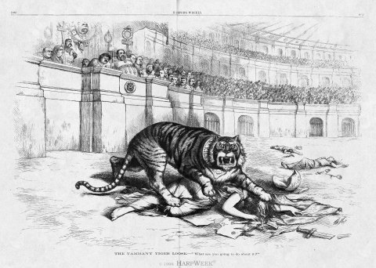
The federal government began to go after corruption in the cities. Progressive Era reformers at the turn of the century successfully compelled local governments to introduce civil service systems to replace party patronage in government employment. By the 1960s, only a small number of political machines remained in the United States, largely in cities such as Chicago that had been able to escape full-scale civil service reform. Democratic Party reformers undermined these remaining machines between 1968 and 1972, though a handful still exist. The Republican Party of Nassau County, New York, for example, retains control of more than 20,000 patronage jobs in the county.
http://www.socialstudieshelp.com/USRA_Pol_Machines.htm

