**U.S. History EOC Review - PRESIDENTS STUDY GUIDE**

**Federalist Era** (1789-1801)

1. George Washington (1789-1797)

V.P.- John Adams

Secretary of State- Thomas Jefferson

Secretary of Treasury- Alexander Hamilton

**Major Items:** Judiciary Act(1789)

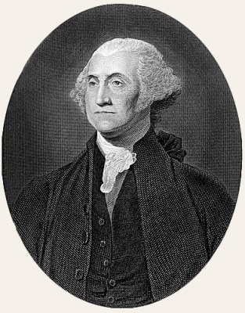 **Bill of Rights**, 1791

**Hamilton’s Financial Plan: 1) Tariffs**

**2) Excise Taxes (Whiskey)**

**3) Assumption of State Debts**

**4) National Bank**

**Whiskey Rebellion** (1794)

French Revolution [(Citizen Genet) (1793)]

**Jay Treaty with England (1795)**

**Battle of Fallen Timbers/Treaty of Greenville** (1895)

**Pinckney Treaty w/ Spain**

**Farewell Address** (1796)

2. John Adams (1797- 1801)

Federalist

VP - Thomas Jefferson

**Major items: X, Y, Z, Affair** (1797)

**“Quasi-War” (1798-1800)**

**Alien Act: Sedition Act (1798)**

**Kentucky and Virginia Resolutions** (1798)

“Midnight Judges” (1801)

[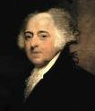](http://www.google.com/imgres?imgurl=http://www.oregonrepublicanparty.org/sites/default/files/quotepics/JohnAdams.jpg&imgrefurl=http://www.oregonrepublicanparty.org/quotes/author/John%20Adams&usg=__Skulrb8K0_WVnSsRbAEbAJCvkkY=&h=400&w=343&sz=20&hl=en&start=4&zoom=1&um=1&itbs=1&tbnid=ZwVNh0ZvrefACM:&tbnh=124&tbnw=106&prev=/search?q=john+adams&um=1&hl=en&safe=active&sa=N&rls=com.microsoft:*:IE-SearchBox&rlz=1I7RNSN_en&biw=1003&bih=543&tbm=isch&ei=M3faTaurCordgQex2oxY)

## Jeffersonian Democracy

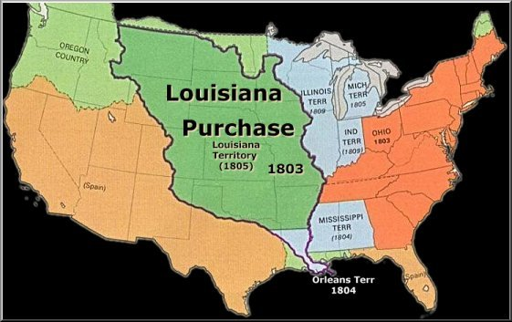

3. Thomas Jefferson (1801-1809)

Republican

V.P.- Aaron Burr

Secretary of State- James Madison

**Major Items: *Marbury vs. Madison*** (1803)

**Louisiana Purchase *(1803)***

Lewis and Clark Expedition (1804-05)

12th Amendment (1804)

Burr Conspiracies, 1804 & 1806

**Embargo Act (1807)**

Non- Intercourse Act (1809)

4. James Madison (1809-1817)

Republican

**Major Items:** “War Hawks” (1811-12)

[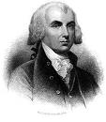](http://www.google.com/imgres?imgurl=http://www.earlyamerica.com/portraits/images/madison.jpg&imgrefurl=http://www.earlyamerica.com/portraits/madison.html&usg=__u6Kh1riNP0zVs9zzVdMeX-18enA=&h=504&w=438&sz=75&hl=en&start=4&zoom=1&um=1&itbs=1&tbnid=vAhQeZg5Cg9_RM:&tbnh=130&tbnw=113&prev=/search?q=james+madison&um=1&hl=en&safe=active&sa=N&rls=com.microsoft:*:IE-SearchBox&rlz=1I7RNSN_en&biw=1003&bih=543&tbm=isch&ei=0XjaTZzHHoW_gQfJg7BY) **War of 1812**

**Hartford Convention** (1814)

**Clay’s American System:**

**“BIT”**

**1) 2nd BUS**

**2) Internal Improvements**(Madison vetoes internal improvements) **3) 1st Protective Tariff**

#### “Era of Good Feelings”

5. James Monroe (1817-1825)

Republican

Secretary of State- John Quincy Adams

**Major Items:** Marshall’s Decisions: *Fletcher v. Peck* (1810)

*McCulloch v. Maryland* (1819)

*Dartmouth College Case* (1819)

*Gibbons v. Ogden* (1824)

**Florida Purchase Treaty/**Adams-Onis Treaty (1819)

**Missouri Compromise (1820)**

**Panic of 1819**

**Monroe Doctrine**, 1823

[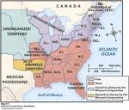](http://www.google.com/imgres?imgurl=http://fc.lovett.org/~lpowell/03788D41-000F4A02.17/mocompromise.jpg&imgrefurl=http://fc.lovett.org/~lpowell/Social%20Studies&usg=__pg4WxYIqptW7vetZUzBFyoj9nEM=&h=1072&w=1256&sz=253&hl=en&start=17&zoom=1&um=1&itbs=1&tbnid=-feKu1VAKOYP6M:&tbnh=128&tbnw=150&prev=/search?q=missouri+compromise&um=1&hl=en&safe=active&rls=com.microsoft:*:IE-SearchBox&rlz=1I7RNSN_en&biw=1003&bih=543&tbm=isch&ei=VnnaTZGDBtOSgQeBmPVY)

### Age of Jackson: 1828-1848

[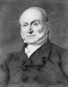](http://www.google.com/imgres?imgurl=http://www.nndb.com/people/370/000026292/jqa.jpg&imgrefurl=http://www.nndb.com/people/370/000026292/&usg=__iaCwXT7YsW31vwxEYQfGTTezFxQ=&h=257&w=200&sz=17&hl=en&start=1&zoom=1&um=1&itbs=1&tbnid=hp4-yF2CjPhoLM:&tbnh=112&tbnw=87&prev=/search?q=john+quincy+adams&um=1&hl=en&safe=active&rls=com.microsoft:*:IE-SearchBox&rlz=1I7RNSN_en&biw=1003&bih=543&tbm=isch&ei=rHnaTbeVEcbDgQeqy-BX)

6. John Quincy Adams (1825-1829)

National Republican

VP- John C. Calhoun

Secretary of State- Henry Clay

**Major Items: “Corrupt Bargain”, 1824**

New York’s Erie Canal (1825)

**Tariff of Abominations** (1828)

Calhoun’s Exposition and Protest (1828)

7. Andrew Jackson (1825-1837)

Democrat

VP- John C. Calhoun, Martin Van Buren

[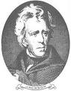](http://www.google.com/imgres?imgurl=http://lincoln.lib.niu.edu/gal/jackson2.jpg&imgrefurl=http://lincoln.lib.niu.edu/gal/jackson2.html&usg=__3xLIy0VYrzILuiTsJrvfMnwuc7A=&h=370&w=288&sz=25&hl=en&start=19&zoom=1&um=1&itbs=1&tbnid=v5mXW-oZA_3AJM:&tbnh=122&tbnw=95&prev=/search?q=andrew+jackson&um=1&hl=en&safe=active&rls=com.microsoft:*:IE-SearchBox&rlz=1I7RNSN_en&biw=1003&bih=543&tbm=isch&ei=2nnaTYffBMjLgQectZRY) **Major Items:** **“New Democracy”**

**“kitchen cabinet”**

Cabinet crisis

**“spoils system”**

**Nullification Controversy of 1832**

**Jackson kills the BUS, 1832**

**Formation of the Whig Party (1832) (Supports Clay’s American System)**

**[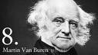](http://www.google.com/imgres?imgurl=http://www.whitehouse.gov/sites/default/files/first-family/masthead_image/8mv_header_sm.jpg?1250871051&imgrefurl=http://www.whitehouse.gov/about/presidents/martinvanburen&usg=__uum22Qm8-aM-lxIsGAhIew74RX0=&h=254&w=450&sz=57&hl=en&start=7&zoom=1&um=1&itbs=1&tbnid=edCXpzsHzkcaNM:&tbnh=72&tbnw=127&prev=/search?q=martin+van+buren&um=1&hl=en&safe=active&rls=com.microsoft:*:IE-SearchBox&rlz=1I7RNSN_en&biw=1003&bih=543&tbm=isch&ei=H3raTfWKJcPIgQe4sPBX) “Trail of Tears”**

8. Martin Van Buren (1837-1841)

Democrat

[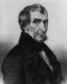](http://www.google.com/imgres?imgurl=http://www.quotesup.com/_Images/Thumbnails/William%20Henry%20Harrison.png&imgrefurl=http://www.quotesup.com/ShowAuthor.aspx?Author=27295&usg=__zOEtZGKSkfxERysVrASBGJIn2vM=&h=198&w=160&sz=36&hl=en&start=10&zoom=0&um=1&itbs=1&tbnid=CH38jAjQbPCR0M:&tbnh=104&tbnw=84&prev=/search?q=william+henry+harrison&um=1&hl=en&safe=active&rls=com.microsoft:*:IE-SearchBox&rlz=1I7RNSN_en&biw=1003&bih=543&tbm=isch&ei=THraTbSDNYTMgQel_JhY) **Major Items: Panic of 1837**

9. William Henry Harrison (1841)

Whig

**Major items:** Election of 1840 (1st modern election—mass politics)

10. John Tyler (1841-1845)

Anti- Jackson Democrat ran as VP on Whig Ticket

Secretary of State- Daniel Webster

[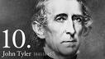](http://www.google.com/imgres?imgurl=http://www.whitehouse.gov/sites/default/files/first-family/masthead_image/10jt_header_sm.jpg?1250871449&imgrefurl=http://www.whitehouse.gov/about/presidents/johntyler&usg=__xjDvqS0NJSETiyXP1CMmm_aUhE8=&h=254&w=450&sz=57&hl=en&start=6&zoom=1&um=1&itbs=1&tbnid=C4mYfG3ULR7SPM:&tbnh=72&tbnw=127&prev=/search?q=john+tyler&um=1&hl=en&safe=active&rls=com.microsoft:*:IE-SearchBox&rlz=1I7RNSN_en&biw=1003&bih=543&tbm=isch&ei=lXraTfzZCYXYgQeN_b1Y) **Major items:**

Vetoes Clay’s Bill of 3rd B.U.S.

**Annexation of Texas (1845)**

##### Manifest Destiny – 1840s

[http://t2.gstatic.com/images?q=tbn:ANd9GcTqKNGc-vPyYrGN5h7EqJOybhjSs7oUW_aSCzq8JNoF_Lv_rQOqKTPeZb7E](http://www.google.com/imgres?imgurl=http://americanhistory.mrdonn.org/banner_manifest_destiny.gif&imgrefurl=http://americanhistory.mrdonn.org/manifestdestiny.html&usg=__ObBIGbb5eDdFNE7BwKlvEqlhHhI=&h=309&w=709&sz=37&hl=en&start=3&zoom=1&um=1&itbs=1&tbnid=9SU2kPY4HrUqOM:&tbnh=61&tbnw=140&prev=/search?q=manifest+destiny&um=1&hl=en&safe=active&rls=com.microsoft:*:IE-SearchBox&rlz=1I7RNSN_en&biw=1003&bih=543&tbm=isch&ei=CnvaTYLqEcPogQfotu1X)11. James K. Polk (1845- 1849)

Democrat

**Major Items: Manifest Destiny: TOM (Texas, Oregon, Mexico)**

**[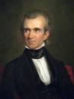](http://www.google.com/imgres?imgurl=http://americangallery.files.wordpress.com/2009/05/small_james-k-polk-george-pahealy.jpg?w=382&h=512&imgrefurl=http://americangallery.wordpress.com/2009/05/06/&usg=__Q2M6p4PMjqBkMAdQrdJOJfY2bnI=&h=512&w=382&sz=28&hl=en&start=8&zoom=1&um=1&itbs=1&tbnid=ANp6tWA2NYgu0M:&tbnh=131&tbnw=98&prev=/search?q=james+k+polk&um=1&hl=en&safe=active&rls=com.microsoft:*:IE-SearchBox&rlz=1I7RNSN_en&biw=1003&bih=543&tbm=isch&ei=RXvaTd3jMojWgQfb-oFY)** Texas becomes a state (1845)

**Oregon Treaty (1846)**

**Mexican War (1846- 1848)**

**Guadalupe-Hidalgo Treaty** (1848)

COIL = **4 Point Plan: CA, OR, Independent Treasury System, Lower Tariff**

**Wilmot Proviso**

**1850’s- Road to Civil War**

[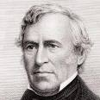](http://www.google.com/imgres?imgurl=http://www.independent.co.uk/multimedia/archive/00113/zachary-taylor_113841t.jpg&imgrefurl=http://www.independent.co.uk/news/presidents/zachary-taylor-1391120.html&usg=__hcfhtGg89ggqvvE4rf1RY5uggGM=&h=300&w=300&sz=24&hl=en&start=6&zoom=1&um=1&itbs=1&tbnid=w8YJBL4DJY5QTM:&tbnh=116&tbnw=116&prev=/search?q=zachary+taylor&um=1&hl=en&safe=active&rls=com.microsoft:*:IE-SearchBox&rlz=1I7RNSN_en&biw=1003&bih=543&tbm=isch&ei=bXvaTaDcJsvOgAeJ2MlY)12. Zachary Taylor (1849-1850)

Whig

VP- Millard Fillmore

**Major Items:** Blocks Compromise of 1850

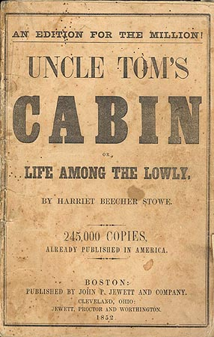

13. Millard Fillmore (1850-1853)

Whig

Secretary of State- Daniel Webster

**Major Items: Compromise of 1850**

Clayton Bulwer Treaty (1850)

***Uncle Tom’s Cabin*** (1852)

[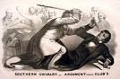](http://www.google.com/imgres?imgurl=http://www.civilwaracademy.com/images/bleeding-kansas.jpg&imgrefurl=http://www.civilwaracademy.com/bleeding-kansas.html&usg=__Aow7g4-qh-5qJiDRI81qjxzvp5U=&h=370&w=565&sz=68&hl=en&start=2&zoom=1&um=1&itbs=1&tbnid=Ib8ykQbYOtsuLM:&tbnh=88&tbnw=134&prev=/search?q=bleeding+kansas&um=1&hl=en&safe=active&rls=com.microsoft:*:IE-SearchBox&rlz=1I7RNSN_en&biw=1003&bih=543&tbm=isch&ei=H3zaTYSPNIHdgQe3oMxX)14. Franklin Pierce (1853-1857)

Democrat

VP- King

**Major Items: Kansas-Nebraska Act (1854)**

“**Bleeding Kansas”**

Japan opened to world trade (1853) – Commodore Perry

Underground Railroad: Harriet Tubman

15. James Buchanan (1857-1861)

Democrat

[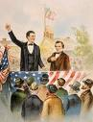](http://www.google.com/imgres?imgurl=http://orrinwoodward.blogharbor.com/Lincoln-Douglas.jpg&imgrefurl=http://orrinwoodward.blogharbor.com/blog/_archives/2007/11/30/3383697.html&usg=__5po2e349pAEUYrfUbPO3DCED5es=&h=450&w=342&sz=30&hl=en&start=4&zoom=1&um=1&itbs=1&tbnid=Ai2bArezGoE1HM:&tbnh=127&tbnw=97&prev=/search?q=lincoln-douglas+debates&um=1&hl=en&safe=active&rls=com.microsoft:*:IE-SearchBox&rlz=1I7RNSN_en&biw=1003&bih=543&tbm=isch&ei=zXzaTYLpKYrUgAfLxJRY) **Major Items:** Taney’s ***Dred Scott Decision*** (1857)

**Lincoln- Douglas Debates** (1858)

Secession (did nothing to prevent it)

[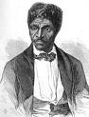](http://www.google.com/imgres?imgurl=http://www.glogster.com/media/2/9/9/65/9096595.jpg&imgrefurl=http://www.glogster.com/glog.php?glog_id=5346830&scale=54&isprofile=true&usg=__6CwHQwuJ8QxMjck3tv3GaJdNtvI=&h=383&w=294&sz=59&hl=en&start=2&zoom=1&um=1&itbs=1&tbnid=u9OljsQUcuipoM:&tbnh=123&tbnw=94&prev=/search?q=dred+scott+case&um=1&hl=en&safe=active&sa=N&rls=com.microsoft:*:IE-SearchBox&rlz=1I7RNSN_en&biw=1003&bih=543&tbm=isch&ei=jXzaTcTqJIHfgQegxfVX)

[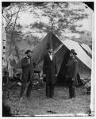](http://www.google.com/imgres?imgurl=http://www.vikitr.net/data/media/4/1_civil-war.jpg&imgrefurl=http://www.vikitr.net/details.php?image_id=722&sessionid=742122a40b1454f5954a18a925de89c5&usg=__VceEs9Gv5bdu9JmInyqTttbsRek=&h=1024&w=825&sz=147&hl=en&start=19&zoom=1&um=1&itbs=1&tbnid=0U0N9s6OA54QqM:&tbnh=150&tbnw=121&prev=/search?q=civil+war&um=1&hl=en&safe=active&rls=com.microsoft:*:IE-SearchBox&rlz=1I7RNSN_en&biw=1003&bih=543&tbm=isch&ei=UH3aTa68BcmcgQfjl9xX)

**Civil War Era (1861-1865)**

16. Abraham Lincoln (1861-1865)

Republican

VP- Andrew Johnson

**Major Items: Civil War (1861-1865)**

**[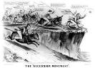](http://www.google.com/imgres?imgurl=http://cwmemory.com/wp-content/uploads/2010/12/secession-cartoon.jpg&imgrefurl=http://cwmemory.com/2010/12/20/hardball-strikes-out-on-secession/&usg=__qkLeSJ1UKBH9qA34kWMUIF-uegw=&h=391&w=550&sz=107&hl=en&start=1&zoom=1&um=1&itbs=1&tbnid=hN7XpZE8Ma3y6M:&tbnh=95&tbnw=133&prev=/search?q=southern+secession&um=1&hl=en&safe=active&rls=com.microsoft:*:IE-SearchBox&rlz=1I7RNSN_en&biw=1003&bih=543&tbm=isch&ei=KH3aTYOFDo7UgQeP5-xX)** Emancipation Acts (1862); **Emancipation Proclamation (1863)**

Homestead Act (1862)

Morrill Tariff (1862)

Pacific Railway Act (1863)

National Banking Act (1862)

Morrill Land Grant Act: created agricultural colleges

**Lincoln’s Assassination,** John Wilkes Booth

#### Reconstruction (1865- 1877) & Gilded Age

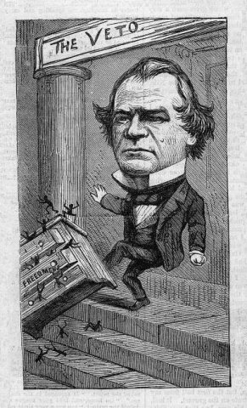

17. Andrew Johnson (1865-1869)

Republican

Secretary of State- W.H. Seward

[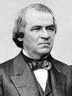](http://www.google.com/imgres?imgurl=http://cdn.dipity.com/uploads/events/aa84af0e68fc1995e67ae1f777798b4a_1M.png&imgrefurl=http://www.dipity.com/bankers/US-History/&usg=__YvZ9GjLLgxc6GeUKkiLt2jc2z-s=&h=480&w=360&sz=114&hl=en&start=18&zoom=1&um=1&itbs=1&tbnid=YpyO2LlyuEbscM:&tbnh=129&tbnw=97&prev=/search?q=tenure+of+office+act&um=1&hl=en&safe=active&rls=com.microsoft:*:IE-SearchBox&rlz=1I7RNSN_en&biw=1003&bih=543&tbm=isch&ei=hH3aTfW-HdDOgAf1r-RX) Major Items: **13th Amendment (1865)**

**14th Amendment (1868)**

**Freedman’s Bureau**

**Black Codes**

**Reconstruction Act (1867)**

**Tenure of Office Act**

Impeachment Trial (1868)

KKK

18. Ulysses S. Grant (1869- 1877)

Republican

**Major items:** 1st Transcontinental Railroad (1869)

**15th Amendment t (1870)**

***[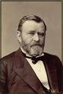](http://www.google.com/imgres?imgurl=http://www.aztecclub.com/biopix/Grant1880.jpg&imgrefurl=http://www.aztecclub.com/grant/grant-index.htm&usg=__y9ui7695UB8WMAlTUML1oqZw7nY=&h=421&w=283&sz=30&hl=en&start=3&zoom=1&um=1&itbs=1&tbnid=k4yNhaSH3gllhM:&tbnh=125&tbnw=84&prev=/images?q=ulysses+s+grant&um=1&hl=en&safe=active&sa=X&rls=com.microsoft:*:IE-SearchBox&rlz=1I7RNSN_en&biw=1003&bih=582&tbm=isch&ei=On7aTeLPO8O_gQfmqbRY)* Panic of 1873**

Corruption- **Tweed Ring**

**Credit Moblier**

**Whiskey Ring**

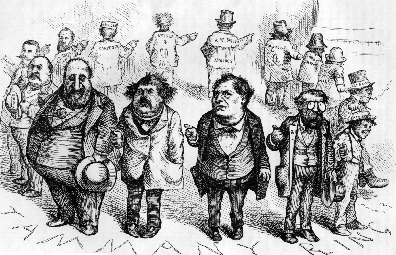

**Gilded Age (1865-1900)**

[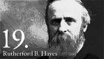](http://popartmachine.com/machine/daily/2009-02-14/portraits-presidents-of-the-united-states-of-america/source__19-rutherford-b-hayes-pop-art-portraitOpium%20Secrets.jpg)19. Rutherford B. Hayes (1877-1881)

Republican

**Major Items: Compromise of 1877 – ENDS RECONSTRUCTION!**

* Withdraw troops from south
* Money for internal improvements
* Conservative southerner in the cabinet

Great Railroad Strike, 1877

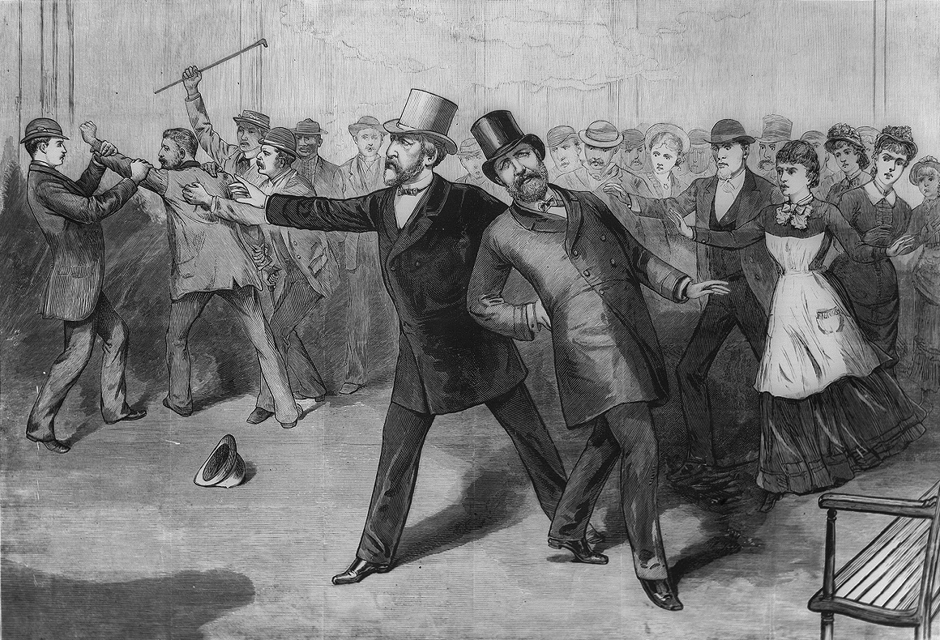 ***Munn v. Illinois*** (1877)

20. James A. Garfield (1881)

[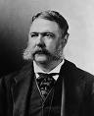](http://www.google.com/imgres?imgurl=http://upload.wikimedia.org/wikipedia/commons/f/fb/Chester_Arthur_1880.jpg&imgrefurl=http://commons.wikimedia.org/wiki/File:Chester_Arthur_1880.jpg&usg=__VLzUiYdNUy2G1WYWe27x3T_MnXU=&h=320&w=260&sz=23&hl=en&start=5&zoom=1&itbs=1&tbnid=FxzLwc1Ts72jMM:&tbnh=118&tbnw=96&prev=/images?q=chester+arthur&hl=en&safe=active&rls=com.microsoft:*:IE-SearchBox&rlz=1I7RNSN_en&tbm=isch&ei=nYzaTZ_aE9DOgAf1r-RX) Republican

**Major Items:** Garfield’s Assassination

21. Chester A. Arthur (1881-1885)

Republican

Major Items: **Pendleton Act** (1883), Civil Service Commission set up

22. Grover Cleveland (1885- 1889)

Democrat

[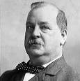](http://www.google.com/imgres?imgurl=http://bloximages.newyork1.vip.townnews.com/stltoday.com/content/tncms/assets/editorial/4/6a/277/46a2779a-7c15-11e0-9b9d-0019bb30f31a-revisions/4dcafeed6416a.image.jpg&imgrefurl=http://www.stltoday.com/entertainment/books-and-literature/book-blog/article_765839b6-7c15-11e0-b473-0019bb30f31a.html&usg=__axrR8uVHaXA2uFm5755QG5QtRNQ=&h=303&w=300&sz=7&hl=en&start=2&zoom=1&itbs=1&tbnid=JSEqgCO_tEiZVM:&tbnh=116&tbnw=115&prev=/images?q=grover+cleveland&hl=en&safe=active&rls=com.microsoft:*:IE-SearchBox&rlz=1I7RNSN_en&tbm=isch&ei=0IzaTdLtK4ODgAeRp51Y) **Major Items: Knights of Labor**; **Haymarket Square Bombing** (1886)

***Wabash vs. Illinois*** (1886)

Interstate Commerce Act (1887)

1887 Annual Address: seeks to lower tariff

[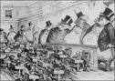](http://www.google.com/imgres?imgurl=http://wa8.wikispaces.com/file/view/fat_guys.jpg/158492643/fat_guys.jpg&imgrefurl=http://wa8.wikispaces.com/sherman+antitrust+act&usg=__RiGmOoDQe3L2PMPJ-TkuXLGH0ww=&h=300&w=425&sz=110&hl=en&start=4&zoom=1&itbs=1&tbnid=g2G2LQrLP4kBDM:&tbnh=89&tbnw=126&prev=/images?q=sherman+antitrust+act&hl=en&safe=active&rls=com.microsoft:*:IE-SearchBox&rlz=1I7RNSN_en&tbm=isch&ei=W43aTcC6A8HYgAfNkqBY) **Dawes Severalty Act**, 1887

23. Benjamin Harrison (1889- 1893)

[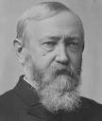](http://www.google.com/imgres?imgurl=http://www.historyplace.com/specials/calendar/docs-pix/ben-harrison.jpg&imgrefurl=http://www.historyplace.com/specials/portraits/presidents/index.html&usg=__XeiBilqhIyU2Se-3ZgSE2HD0Lpg=&h=466&w=394&sz=41&hl=en&start=3&zoom=1&itbs=1&tbnid=NWzvZcdW9qfq-M:&tbnh=128&tbnw=108&prev=/images?q=benjamin+harrison&hl=en&safe=active&rls=com.microsoft:*:IE-SearchBox&rlz=1I7RNSN_en&tbm=isch&ei=MI3aTcmFHYbpgQe_k5BY) Republican

**Major Items: Sherman Anti-Trust Act (1890)**

**McKinley Tariff (1890)**

**Homestead Steel Strike, 1892**

**Populist Party Platform of 1892 (Omaha Platform)**

24. Grover Cleveland (1893- 1897)

Second Administration

Democrat

[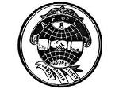](http://www.google.com/imgres?imgurl=http://www.xtimeline.com/__UserPic_Large/3621/ELT200711210140570624920.GIF&imgrefurl=http://www.xtimeline.com/evt/view.aspx?id=43243&usg=__HL5WbSyvZCQSk6bsPBU_4MHe6ng=&h=1125&w=1500&sz=191&hl=en&start=1&zoom=1&itbs=1&tbnid=IR2vM3Dqqh5V2M:&tbnh=113&tbnw=150&prev=/images?q=american+federation+of+labor&hl=en&safe=active&rls=com.microsoft:*:IE-SearchBox&rlz=1I7RNSN_en&tbm=isch&ei=oI3aTen2CoHfgQegxfVX) **Major Items: Panic of 1893**

[](http://www.google.com/imgres?imgurl=http://bloximages.newyork1.vip.townnews.com/stltoday.com/content/tncms/assets/editorial/4/6a/277/46a2779a-7c15-11e0-9b9d-0019bb30f31a-revisions/4dcafeed6416a.image.jpg&imgrefurl=http://www.stltoday.com/entertainment/books-and-literature/book-blog/article_765839b6-7c15-11e0-b473-0019bb30f31a.html&usg=__axrR8uVHaXA2uFm5755QG5QtRNQ=&h=303&w=300&sz=7&hl=en&start=2&zoom=1&itbs=1&tbnid=JSEqgCO_tEiZVM:&tbnh=116&tbnw=115&prev=/images?q=grover+cleveland&hl=en&safe=active&rls=com.microsoft:*:IE-SearchBox&rlz=1I7RNSN_en&tbm=isch&ei=0IzaTdLtK4ODgAeRp51Y) **Pullman Strike (1894)**

# Coxey’s Army

**American Federation of Labor (AF of L)**

Wilson-Gorman Tariff

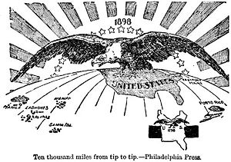25. William McKinley (1897- 1901)

**Election of 1896- Wizard of Oz**

Republican

VP- Theodore Roosevelt (in 1901)

Secretary of State- John Hay

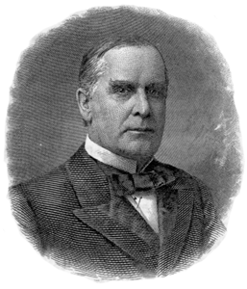 **Major Items:** New Imperialism

**Spanish American War (April 1898- Feb. 1899)**

**Open Door Policy (1899)**

[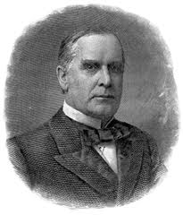](http://www.google.com/imgres?imgurl=http://www.bartleby.com/124/mckinley.gif&imgrefurl=http://www.bartleby.com/124/pres40.html&usg=__NHqoAyHomaI_WRsigd4987clYBM=&h=300&w=257&sz=70&hl=en&start=6&zoom=1&tbnid=SEftXEYt2Nc64M:&tbnh=116&tbnw=99&ei=0PDaTb6FDYj6sAO0hYGsDg&prev=/search?q=william+mckinley&hl=en&sa=X&biw=1345&bih=553&tbm=isch&prmd=ivnso&itbs=1)Boxer Rebellion (1900)

[](http://www.google.com/imgres?imgurl=http://www.bartleby.com/124/mckinley.gif&imgrefurl=http://www.bartleby.com/124/pres40.html&usg=__NHqoAyHomaI_WRsigd4987clYBM=&h=300&w=257&sz=70&hl=en&start=6&zoom=1&tbnid=SEftXEYt2Nc64M:&tbnh=116&tbnw=99&ei=0PDaTb6FDYj6sAO0hYGsDg&prev=/search?q=william+mckinley&hl=en&sa=X&biw=1345&bih=553&tbm=isch&prmd=ivnso&itbs=1) McKinley’s Assassination/ Leon Czolgosz (1901)

[](http://www.google.com/imgres?imgurl=http://www.bartleby.com/124/mckinley.gif&imgrefurl=http://www.bartleby.com/124/pres40.html&usg=__NHqoAyHomaI_WRsigd4987clYBM=&h=300&w=257&sz=70&hl=en&start=6&zoom=1&tbnid=SEftXEYt2Nc64M:&tbnh=116&tbnw=99&ei=0PDaTb6FDYj6sAO0hYGsDg&prev=/search?q=william+mckinley&hl=en&sa=X&biw=1345&bih=553&tbm=isch&prmd=ivnso&itbs=1)

**Progressive Era** (1900-1920)

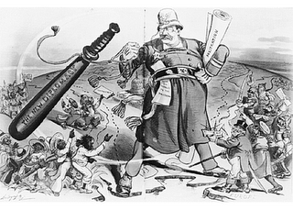26. Theodore Roosevelt (1901-1909)

Republican

Secretary of State- John Hay, Elihu Root

**Major items: “Big Stick” Diplomacy**

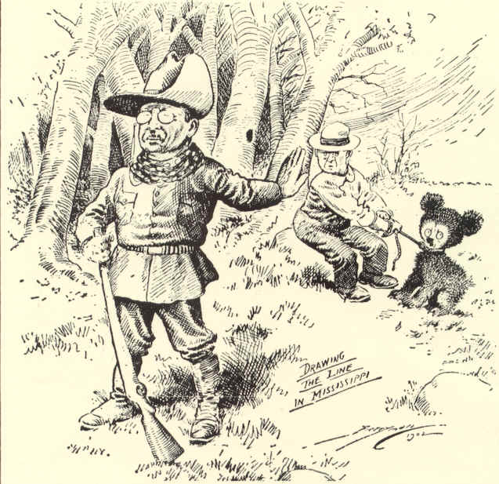**Panama Canal (1903- 1914)- “Gunboat Diplomacy”**

**Roosevelt Corollary to the Monroe Doctrine (1904)**

Portsmouth Treaty (1905) -- Nobel Peace Prize

**Gentleman’s Agreement** with Japan (1908)

Political Reforms of the Roosevelt Era

[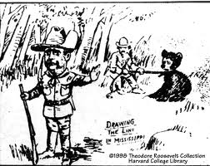](http://www.google.com/imgres?imgurl=http://www.theodoreroosevelt.org/graph%20harv%20col/HC1x8.gif&imgrefurl=http://www.theodoreroosevelt.org/life/biopictures.htm&usg=__T6onNJGdD3vEgpd-ro_pEmTUGkE=&h=518&w=651&sz=198&hl=en&start=3&zoom=1&tbnid=31Q2Q9GXcHxJ_M:&tbnh=110&tbnw=138&ei=k_HaTa3QCMzciALp59iACA&prev=/search?q=theodore+roosevelt+political+cartoon&hl=en&biw=1345&bih=553&tbm=isch&itbs=1) **Muckrakers**

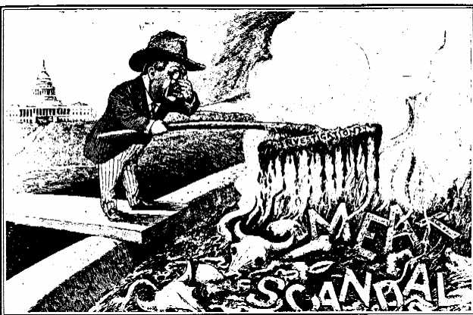 **3 C’s: Consumer Protection,**

Pure Food and Drug Act, Meat Inspection Act

**Control of Corporations**

**Anthracite Coal Strike**, 1902

**Trustbusting**

**Conservation**

Newlands Reclamation Act, Nat’l Parks

27. William H. Taft (1909-1913)

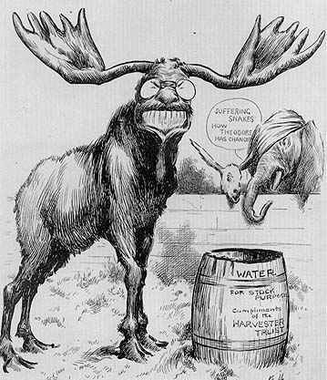 Republican

**Major Items:** **Paine- Aldrich Tariff (1909)**

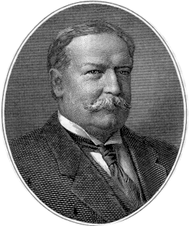 **Pinchot-Ballinger Controversy**

Trustbusting- Standard Oil

**“Dollar Diplomacy”**

**Split in Republican Party- Bull Moose Party**

[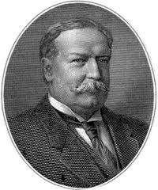](http://www.google.com/imgres?imgurl=http://www.bartleby.com/124/taft.gif&imgrefurl=http://www.bartleby.com/124/pres43.html&usg=__ildc5wsK70hsC7HH7oBAT-TFu3w=&h=300&w=251&sz=70&hl=en&start=30&zoom=1&tbnid=_O3_dW64KB1EPM:&tbnh=123&tbnw=103&ei=R_faTcbxK8XiiALguYyCCA&prev=/search?q=william+howard+taft&hl=en&biw=1345&bih=553&tbm=isch&itbs=1&iact=hc&vpx=118&vpy=202&dur=16&hovh=240&hovw=200&tx=111&ty=268&sqi=2&page=2&ndsp=29&ved=1t:429,r:0,s:30)

28. Woodrow Wilson (1913-1921)

Democrat

**Major Items: *“*New Freedom”: anti-triple wall of privilege: Tariffs, The banks, Trusts**

**Underwood Tariff (1913)**

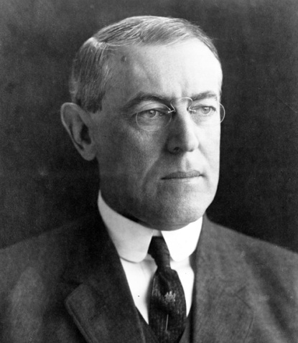 **Federal Reserve System (1913)**

**Federal Trade Commission (1914)**

**Clayton Anti-Trust Act (1914)**

Troops to Mexico, Nicaragua, Dominican Republic, Haiti, Virgin Islands

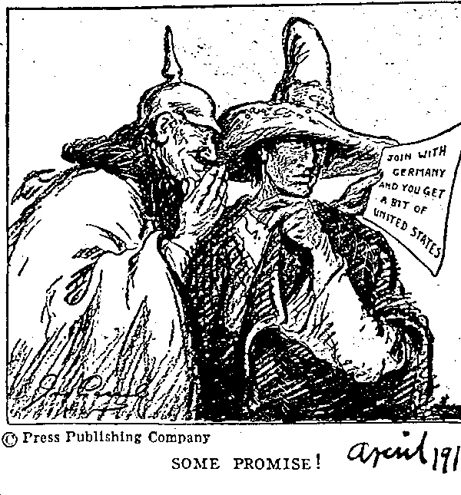 16th, 17th, 18th and 19th Amendments

**WWI:**

***Lusitania* (May, 1915)**

**“Fourteen Points” (Jan., 1917)**

**Treaty of Versailles (1919-1920)**

**League of Nations, Lodge Reservations**

“**Red Scare”**

**Palmer Raids** (1919-1920)

“Red Summer”, 1919 – race riots

**Roaring Twenties (1920-1929)**

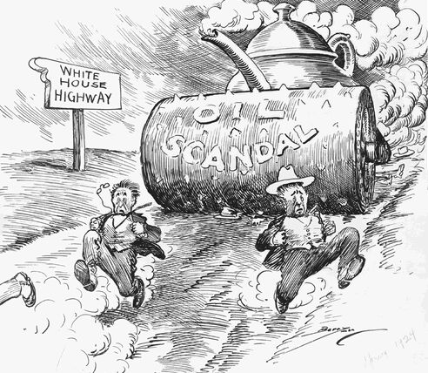**Conservative Presidents (1920-1932)**

29. Warren G. Harding (1921-1923)

Republican

**Major Items: Conservative Agenda**

**Teapot Dome Scandal**

**Washington Disarmament Conference** (1921- 1922)

**“Americanism”- WASP Values**

30. Calvin Coolidge (1923-1929)

Republican

**Major Items: Continuation of Harding’s conservative policies**

[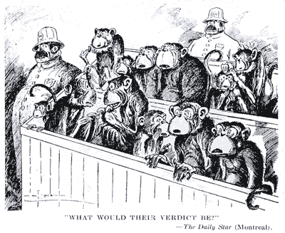](http://faculty.polytechnic.org/gfeldmeth/mon.gif)[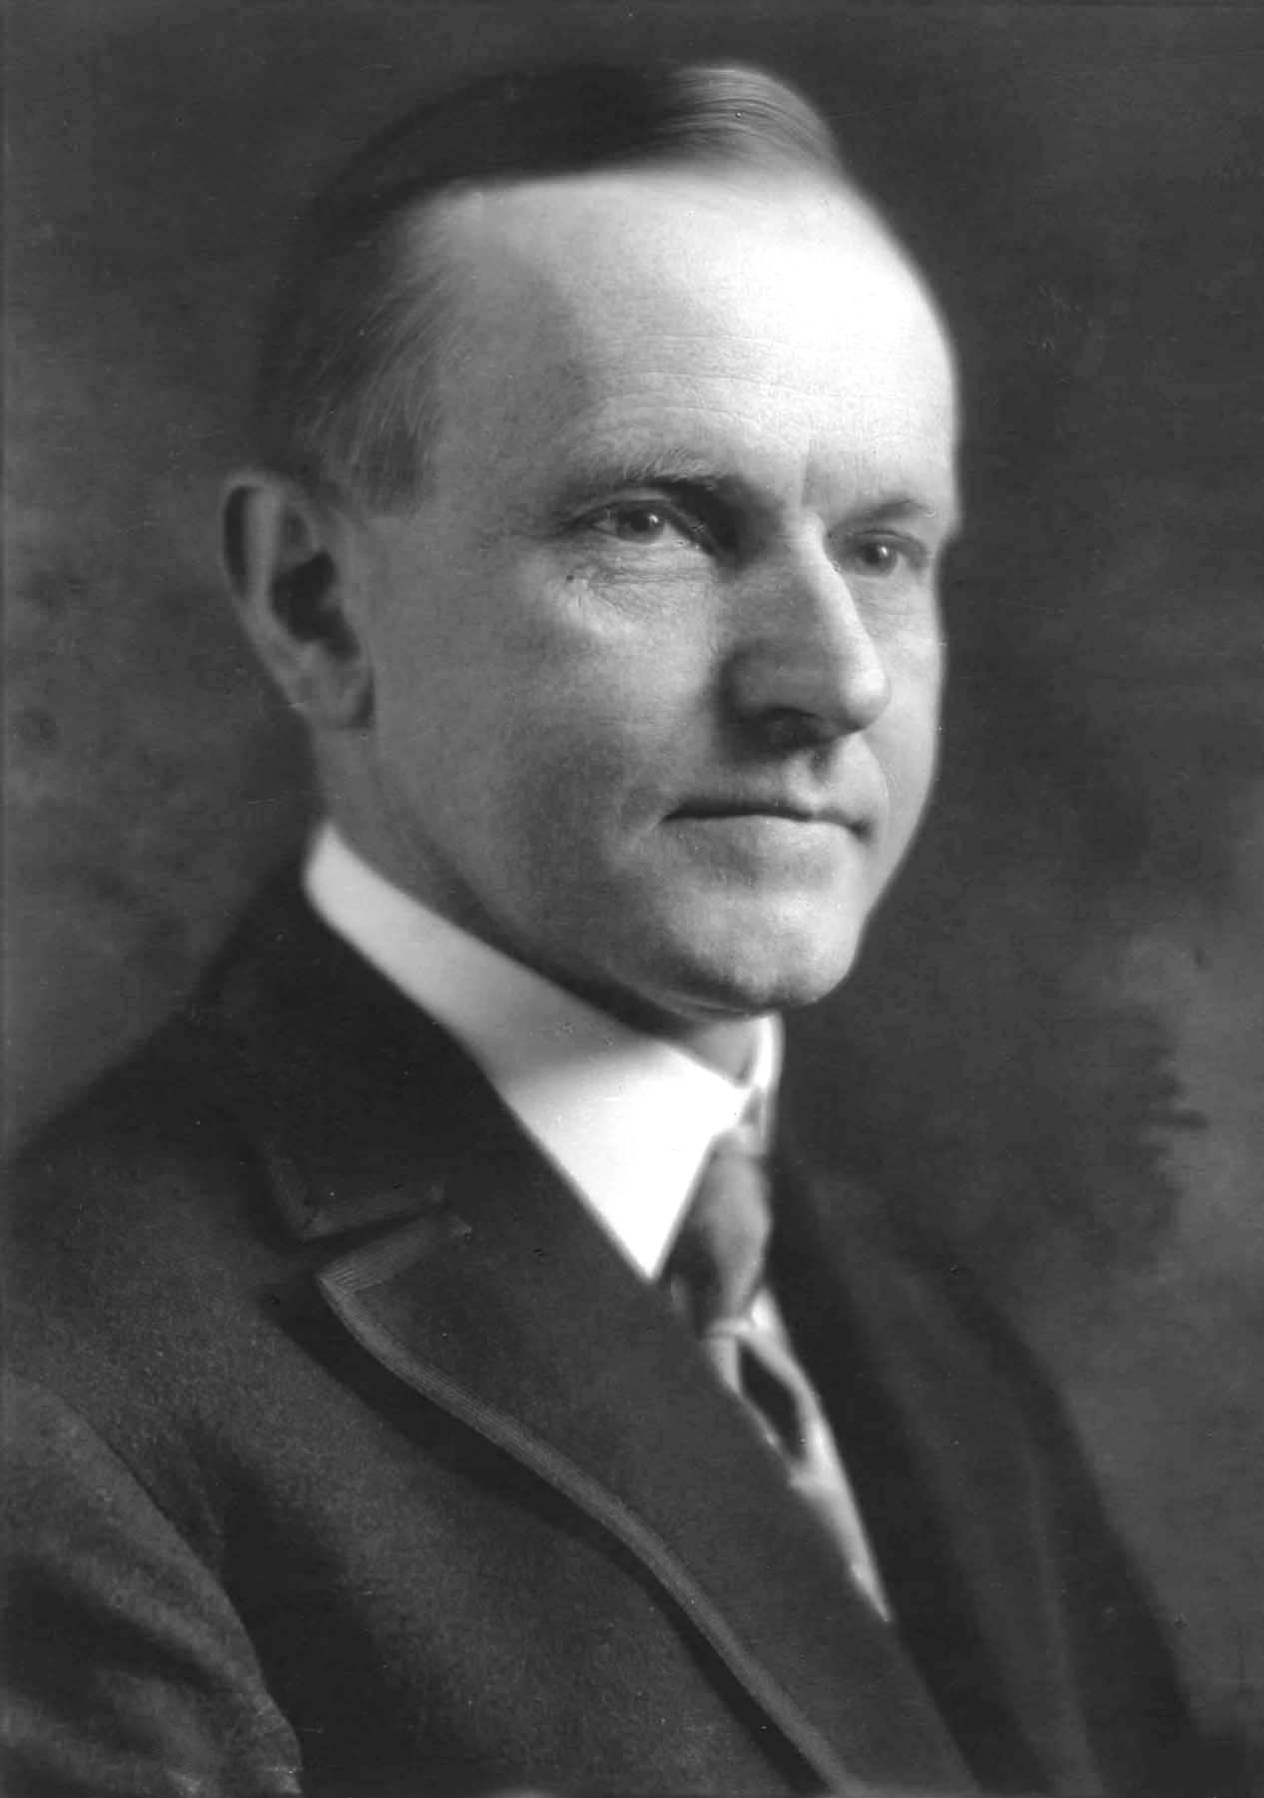](http://www.themoralliberal.com/wp-content/uploads/2010/09/Calvin_Coolidge.jpg)**National Origins Act (1924)**

**Scopes “Monkey” Trial (1925)**

**Sacco Vanzetti Trial**

demise of KKK

**Dawes Plan (1924)**

**Kellogg-Briand Pact (1928)**

[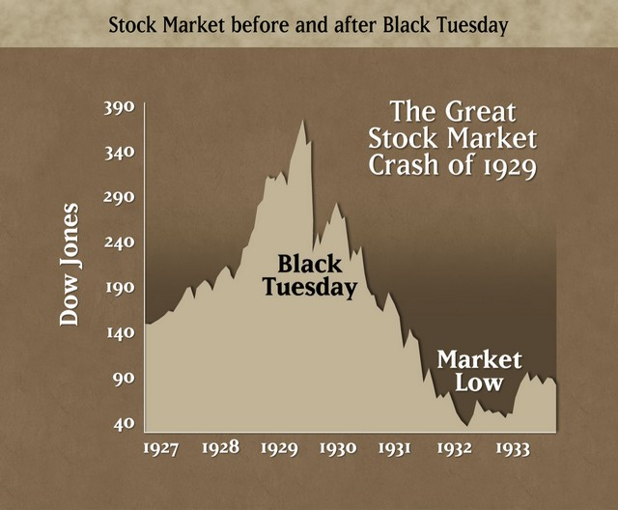](http://static.seekingalpha.com/uploads/2008/11/17/saupload__stock_market_crash_1929.jpg)31. Herbert Hoover (1929-1933)

Republican

**Major Items: Stock Market Crash (1929)**

**Great Depression**

Agricultural Marketing Act, 1929

Hawley- Smoot Tariff (1930)

**Reconstruction Finance Corporation (RFC)**

**Bonus Army**

**The New Deal/WWII** (1933-1945)

32. Franklin D. Roosevelt (1933-1945)

Democrat

Eleanor Roosevelt: African- Americans, children, women

[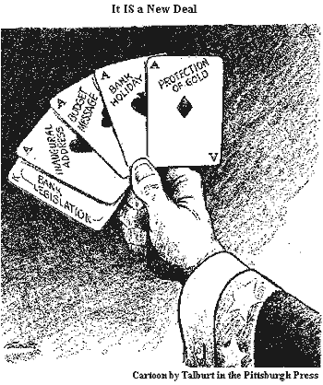](http://www.johndclare.net/images/newdeal.gif) **Major Items: New Deal: Relief, Recovery, Reform**

**Isolationism: Neutrality Laws**

**WWII**

**Labor- CIO (John L. Lewis)**

#### The Cold War

33. Harry S. Truman (1945-1953)

Democrat

**Major Items:** WWII Ends- Atomic Bomb

**Taft-Hartley Act (1947)**

**[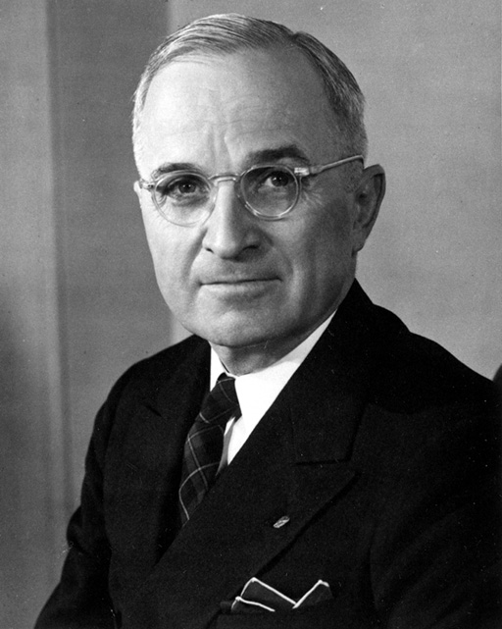](http://4.bp.blogspot.com/-6bYxkGZJCbc/TaPXAyejdoI/AAAAAAAACgI/B_cQzHehqS8/s1600/HarryTruman-President.jpg) Truman’s Loyalty Program**

**Desegregation of Armed Forces, 1948**

**Cold War**

**Truman Doctrine (1947)**

**Marshall Plan (1947)**

**Berlin Crisis, 1948-49**

**North Atlantic Treaty Organization (NATO) (1949)**

**[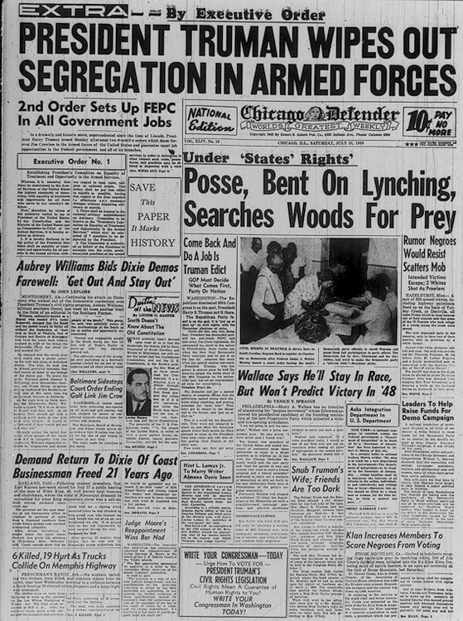](http://lcweb.loc.gov/exhibits/odyssey/archive/09/0902001r.jpg) Korean War (1950-1953)**

[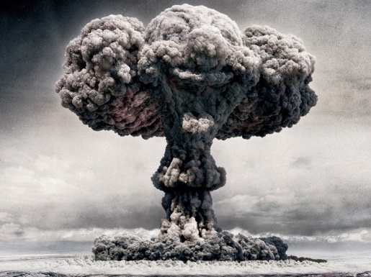](http://desktopwallpaper.im/wallpapers/atomic-bomb-explosion-800x600.jpg)

[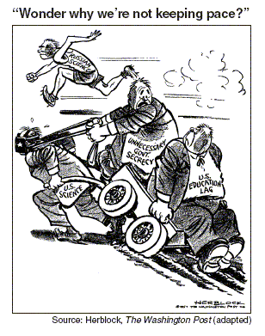](http://regentsprep.org/regents/ushisgov/graphics/6b_3.gif)34. Dwight D. Eisenhower (1953- 1961)

Republican

VP- Richard Nixon

Secretary of State- John Foster Dulles

**Major Items: Cold War**

**[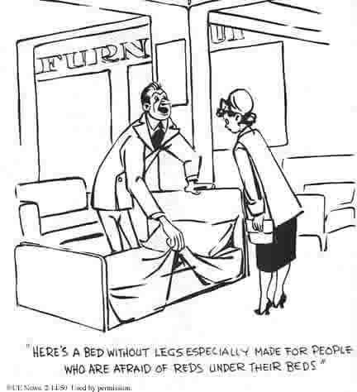](http://academic.evergreen.edu/curricular/ageofirony/aoizine/sarah_files/image003.jpg) “Massive Retaliation”**

H- Bomb

22nd Amendment

Southeast Asia Treaty Organization (S.E.A.T.O.)

**Domino theory**, Vietnam

“Peaceful Cooexistence”

Suez Crisis (1956)

**Sputnik (1957)**

**Eisenhower Doctrine** (1958)

[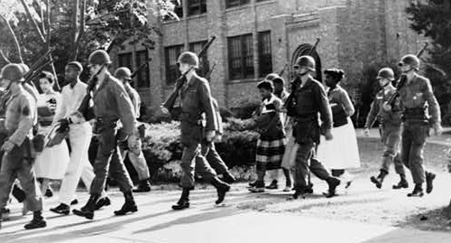](http://desertpeace.files.wordpress.com/2010/09/littlerock1957.gif) **U-2 Incident**, 1960

**Civil Rights**

***Brown vs. Board of Education* (1954)**

**Montgomery Bus Boycott, 1955-56,**

**Martin Luther King**

**Crisis in Little Rock, 1957**

**Greensboro Sit-in, 1960**

**Affluent Society:** Baby Boom, suburbs, consumerism, TV

Federal Highway Act (1955)

Alaska and Hawaii become states (1959)

35. John F. Kennedy (1961-1963)

Democrat

VP- Lyndon B. Johnson

**Major Items: “ The New Frontier”**

**Alliance for Progress**

**The Peace Corps**

**Cuba:**

**Bay of Pigs (1961)**

**Cuban Missile Crisis (1962)**

Nuclear Test- Ban Treaty (1963)

Kennedy assassinated (Nov. 22, 1963), Lee Harvey Oswald

[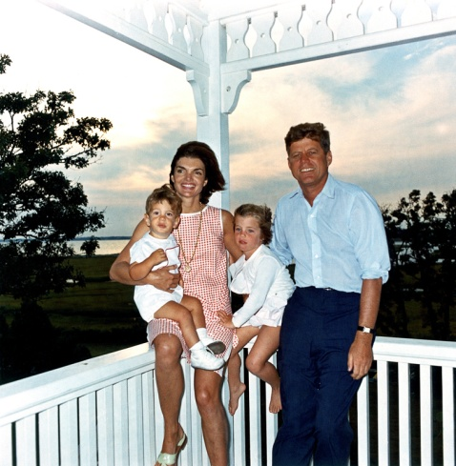](http://upload.wikimedia.org/wikipedia/commons/f/f8/JFK_and_family_in_Hyannis_Port,_04_August_1962.jpg)[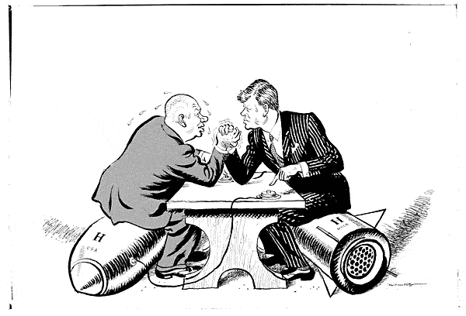](http://telefolios.rcoe.appstate.edu/~at62288/ilw3584.gif)

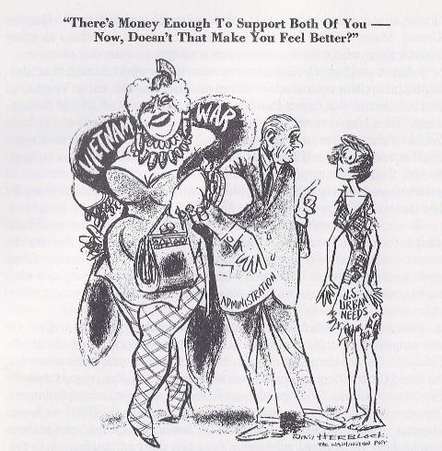

36. Lyndon B. Johnson (1963-1969)

Democrat

**Major Items:** The “Cold War”

**Vietnam, escalation**

***[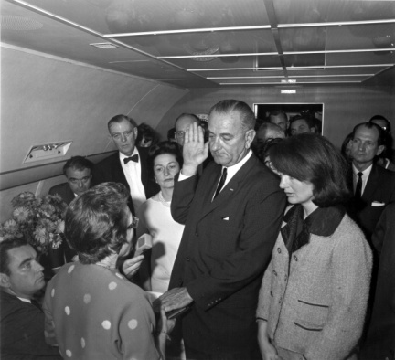](http://danthemantrivia.files.wordpress.com/2009/11/lbj-takes-oath-of-office.jpg)*  “The Great Society”**

**- Anti-poverty Act (1964)**

**- Elementary and Secondary Education**

**- Medicare**

**- Affirmative Action**

Income Tax Cut

**Civil Rights Act (1964)**

**Voting Rights Act (1965)**

**Warren Court (Rights of the Accused)**

“Long Hot Summers”: Watts and Detroit riots

Thurgood Marshall

1968: “Year of Shocks” – Tet, MLK assassinated, Black Power, Nixon wins

## [http://ts1.mm.bing.net/images/thumbnail.aspx?q=967256252488&id=f06a1d126ecdc857e4be2ddf7907d71c&url=http%3a%2f%2fcontent.answcdn.com%2fmain%2fcontent%2fimg%2fgetty%2f7%2f6%2f803476.jpg](http://www.bing.com/images/search?q=nixon&view=detail&id=7B78738D66820F94BC03345FAACE8428366213F7&first=0&FORM=IDFRIR)Détente

37. Richard M. Nixon (1969- 1974)

Republican

VP- Spiro Agnew, Gerald Ford

**Major Items: “**Imperial Presidency”

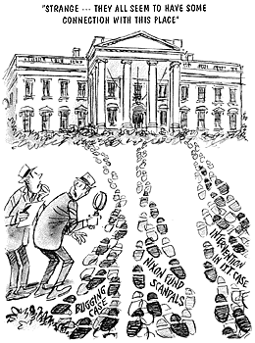 **Vietnam War,** Vietnamization, Cambodia

Landing on the Moon (July, 1969)

**Warren Burger**- Chief Justice (1969) –many socially liberal decisions

 ***Roe v. Wade*** (1973)

Woodstock (Aug., 1969)

E.P.A. established (1970)

Philadelphia Plan: affirmative action

26th Amendment (1971)

“Silent Majority”

**Détente**

**- Visit to China (Feb, 1972)**

**- Visit to Russia (May, 1972)**

**- Salt I (1972)**

**Energy Crisis, OPEC**

Agnew resigns (1973)

[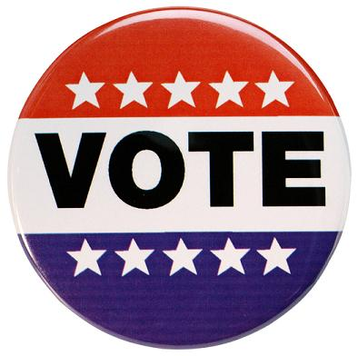](http://images.quickblogcast.com/94499-87566/getoutthevote.jpg?a=91) **Nixon Resigns (Aug. 9, 1974)- Watergate**

[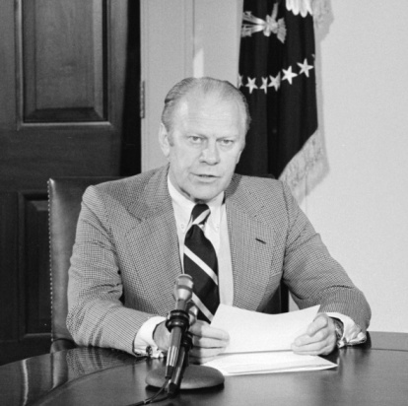](http://upload.wikimedia.org/wikipedia/commons/d/df/GeraldFordDraft.jpg)38. Gerald Ford (1974- 1977)

Republican

First Appointed President

**Major Items:** Pardons Nixon

**Stagflation**

Helsinki Conference, 1975

39. Jimmy Carter (1977-1981)

Democrat

**Major Items: Panama Canal Treaty signed *(Sept, 1977)***

**“Humanitarian Diplomacy”**

***[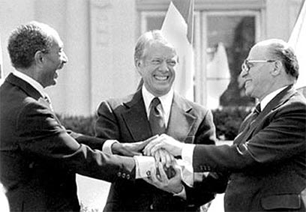](http://static.foreignpolicyjournal.com/wp-content/uploads/2010/10/camp-david.jpg)***  Diplomatic relation with communist China; ended recognition of Taiwan

3 Mile Island Incident (PA), 1979

**Camp David Accords: Egypt and Israel Peace Treaty**

**Iran Hostage Crisis (1979)**

**- Rescue attempt- 8 killed (April, 1980)**

Soviet invasion of Afghanistan Soviets (1979)

**“Stagflation”**

Boycott of Olympics in Moscow to protest Afghanistan (1980)

**1980s, 1990s**

40. Ronald Reagan (1981-1989)

Republican

VP- George Bush

**Major Items:** “**Reaganomics-Supply-Side-Economics”**

**Massive Military Buildup, “Star Wars” (SDI)**

Culture war: “Religious Right”

1500 Marines sent to Beirut (1983); withdrawn 1984

Grenada (Oct, 1983), Nicaragua (1984)

Sandra Day O’ Conner appointed to the Supreme Court (First Woman)

INF Treaty with Soviet Union (Gorbachev)

**Iran Contra Hearings: Oliver North (1987)**

***[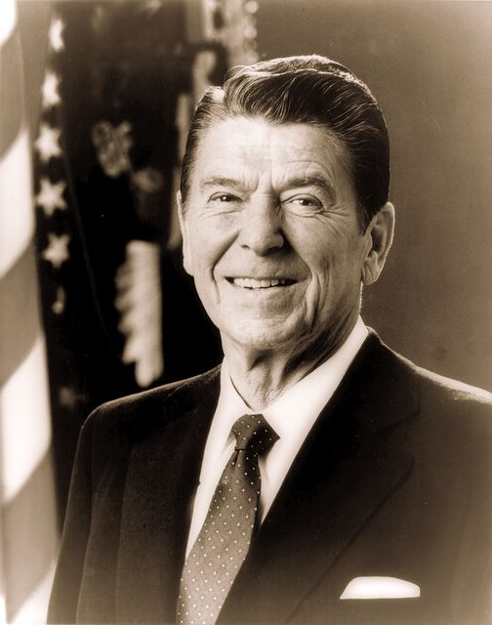](http://www.quipsnquills.com/n1spirit/images/blogimgs/ronald_reagan.jpg)***

***[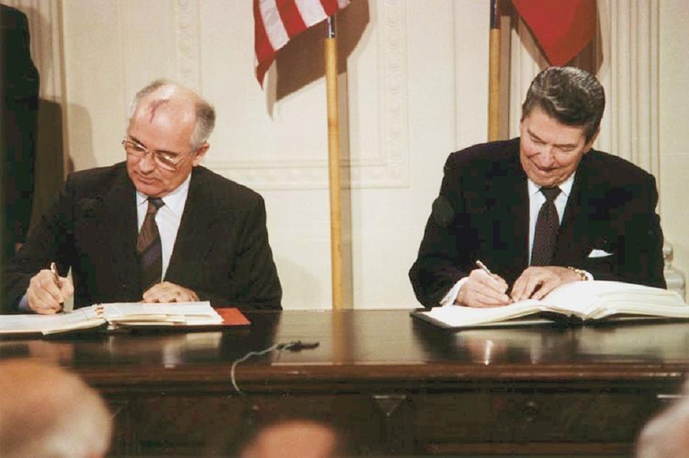](http://02varvara.files.wordpress.com/2008/08/reagan_and_gorbachev_signing-inf-treaty-1987.jpg)***

[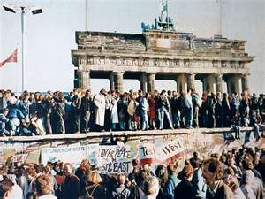](http://www.bing.com/images/search?q=fall+of+berlin+wall&view=detail&id=849E1EF0C8B3126E56B3C25F4ADA8ABA088816C7&first=0&FORM=IDFRIR)[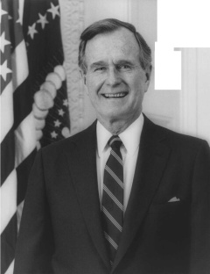](http://upload.wikimedia.org/wikipedia/en/1/11/George_H.W._Bush.jpg)41. George H. W. Bush (1989-1993)

Republican

VP- Dan Quayle

**Major Items:**

**Fall of Berlin Wall, 1989; Revolutions of 1989 in Europe**

**Gulf War I: Operation Desert Storm, 1991**

**Fall of Soviet Union (1991)**

Recession 1992-93

[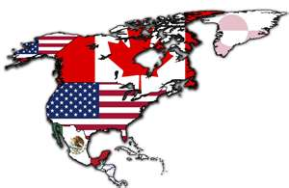](http://www.bing.com/images/search?q=nafta&view=detail&id=6668BEA0A3678E4E8ACEA26BFCC2993208758D97&first=0&FORM=IDFRIR)42. Bill Clinton (1993-2001)

Democrat

VP- Al Gore

**Major Items:** NAFTA

[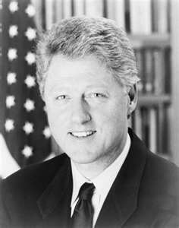](http://www.bing.com/images/search?q=bill+clinton&view=detail&id=90FED6D371D914BE2ABDF420B5A3B3E25DC13273&first=0&FORM=IDFRIR) Republicans take Congress for 1st time in over 40 years

-Contract With America

Welfare Reform

Monica Lewinski Scandal, **impeachment**

**Commits troops to Bosnia on NATO peace-keeping mission**

**War in Kosovo**

43. George W. Bush (2001-2008)

Republican

VP – Dick Cheney

**Major Items:** Disputed election of 2000, Florida

[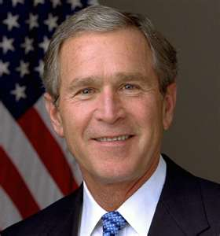](http://www.bing.com/images/search?q=george+w+bush&view=detail&id=3E74944021F4EA87667D621944CB86A61352D262&first=0&FORM=IDFRIR) *Bush v. Gore, 2000*

Major tax cuts

**No Child Left Behind Act**

9/11 terrorist attacks, Osama Bin Laden

War in Afghanistan

Iraq War

***[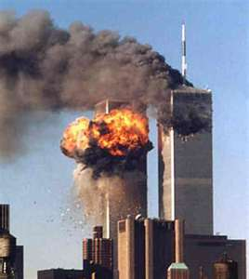](http://www.bing.com/images/search?q=9/11&view=detail&id=F7B47666131D79CAB8C6381BE9E68152E6C12A8F&first=0&FORM=IDFRIR)***

***[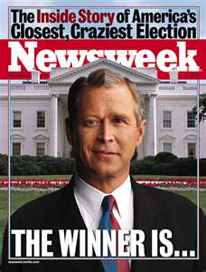](http://www.bing.com/images/search?q=2000+election&view=detail&id=6CC1F644DE235BED03CE11317AF8926D16639738&first=31&FORM=IDFRIR)***