APUSH REVIEW

The following is a list of major themes, concepts, people and events to know and be able to explain why they are important.
UNIT ONE: 1607-1763
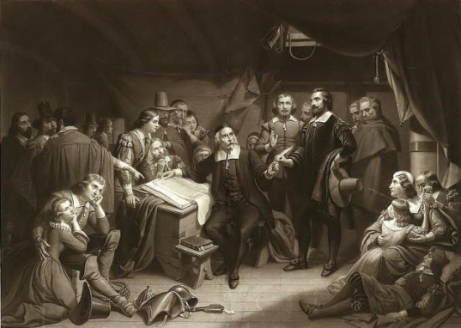
Columbus (reasons for exploration)
Order of colonization of colonies
Mayflower Compact (1620)
Contrast between Pilgrims and Puritans (!)
Puritan migration (1630s)
Church of England
John Winthrop (Puritan, “city upon a hill”)
Calvinism
Congregational Church (stems from Puritanism)
Roger Williams (sep. of church and state)
Anne Hutchinson
covenant theology
Half-way covenant
Thomas Hooker (CT)
Fundamental Orders of Connecticut
Founding of Harvard (1636)
New England Confederation (1643)
King Philips War (1675-1676)
Dominion of New England (1868)
Sir Edmund Andros

SOUTHERN COLONIES:
Jamestown, first colony (1607)
joint stock company
Virginia: purpose, failures, successes
headright system
John Smith
John Rolfe
slavery begins (1619)
House of Burgesses (1619)
Bacon’s Rebellion (1676)
Georgia: reasons, successes
James Oglethorpe (GA)
staple crops

MIDDLE COLONIES
William Penn Holy Experiment
New York: Dutch
Patroon system
Peter Stuyvesant
Five Nations
Crops in the Colonies
Leisler’s Rebellion (1689-1691)
Religion in the colonies
Pennsylvania
Rhode Island
Johnathan Edwards, Sinners in the Hands of an Angry God
Maryland
Old Lights, New Lights
George Whitefield
Lord Baltimore
Maryland Toleration Act
Deism
Huguenots

COLONIAL ECONOMY:
Mercantilism
sectional differences
Navigation Acts
triangular trade
Currency Act

COLONIAL SOCIETY:
Salem Witch Trials
Primogeniture
indentured servants
Phyllis Wheatly-African American poet
“salutary neglect”
Enlightenment
town meetings
John Peter Zenger-libel court case
John Locke-“natural rights” (“life, liberty and property”…Jefferson changed it to “life, liberty and the pursuit of happiness” in the Dec. of Indep)

COMING OF THE AMERICAN REVOLUTION:
writs of assistance
Pontiac’s Rebellion
Paxton Boys
Grenville Program
virtual representation
Stamp Act (1765)/Stamp Act Congress-first time colonies come together to oppose British policies
Virginia Revolves
James Otis
Proclamation of 1763
Navigation Acts (1660)
Sugar Act
non-importation
actual representation
Sons of Liberty
Patrick Henry
internal taxes
external taxes
Declaratory Act (1766)
Townshend Acts (1767)
The Association
Boston Massacre (1770)
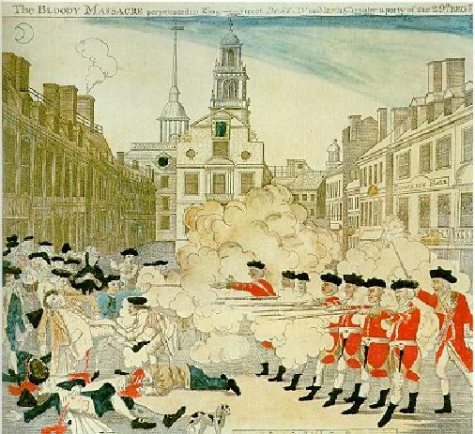
Crispus Attucks

Carolina Regulators
Governor Thomas Hutchinson
Lord North
Boston Tea Party (1773)
East India Company
Coercive Acts/Intolerable Acts
Boston Port Act (1774)
Quebec Act (1774)
First Continental Congress-convened in response to Intolerable Acts
Suffolk Resolves
Continental Association
Paul Revere
George Washington
Olive Branch Petition (1775)-offered to King George III (colonists trying to make peace); he rejects it and announces that colonies are “in rebellion”
“natural rights” philosophy
Richard Henry Lee’s Resolution, July 2
Abigail Adams
Edmund Burke
Lafayette
Benedict Arnold
Articles of Confederation-weak central gov.
Quartering Act (Mutiny Act by the British)
Sam Adams
John Adams
Gaspee Incident (1772)
Committees of Correspondence
Galloway Plan
Lexington and Concord (1775)
Second Continental Congress
Bunker Hill
Thomas Paine, Common Sense (Jan, 1776-this pamphlet encouraged colonists to seek independence from Great Britain)
George III-King of England during A.R.
Committee on Dec. of Independence
Jefferson, Adams, Sherman, Franklin and Livingston
Mercy Otis Warren (wrote about the Revolution)
George Rogers Clark
Robert Morris

UNIT TWO: 1783-1800

Land Ordinance of 1785
Northwest Ordinance of 1787
Shays’ Rebellion
Jay-Gardoqui Treaty (b/w U.S. and Spain, guaranteed Spanish right to Mississippi river, treaty never ratified)
Annapolis Convention
Noah Webster
Alexander Hamilton
James Madison
Montesquieu, Spirit of Laws
Voltaire (freedom of speech, religion)
Jean Jacques Rousseau
Philadelphia Constitution
Plans:
Hamilton
Virginia (large states plan)
New Jersey Plan (small states plan)
Compromises in Constitution:
3/5’s
Great Compromise (two houses)
Federalists (those for the Constitution)
Anti-Federalists (those against Constitution)
Patrick Henry (“give me Liberty..or give me Death”)
Federalist Papers-encouraged ratification of U.S. Constitution, written by Hamilton, Madison and Jay
John Fisk, critical period
George Mason, Bill of Rights

POLITICS OF THE 1790s:

Bill of Rights adopted
Washington becomes president
Judiciary Act of 1789 (set up courts)
Hamilton, Sec. of Treasury
Jefferson, Sec. of State
excise taxes
implied powers clause
strict (Jefferson) v. loose (Hamilton) interpretation
Location of capitol: Washington, D.C.
Whiskey Rebellion
Washington’s Farewell Address-warned nation to stay out of foreign entanglements
Jefferson as Vice President under Adams
Alien and Sedition Acts (1798)-Dem-Rep claimed they were designed to protect the Federalist Party/censorship
Virginia and Kentucky Resolutions
Election of 1800, Burr v. Jefferson
Revolution of 1800 (smooth transfer of power from one party to another)
John Singleton Copley, Charles Wilson Peale, and Gilbert Stuart
artists, painted portraits of founding fathers, etc.

FOREIGN AFFAIRS IN THE 1790s:
French Alliance, 1777-after Battle of Saratoga
French Revolution (1789)
Citizen Genet
Neutrality Proclamation (1793)
XYZ Affair
Talleyrand
Undeclared naval war with France (1799)
Convention of 1800
Jays Treaty (1794, ratified 1796, b/w U.S and Great Britain, averted war)
Pinckney’s Treaty (1795, ratified in 1796, set up borders and “friendship” with Spain)
Treaty of Greenville
Barbary Pirates

UNIT THREE: 1800-1840

Themes:
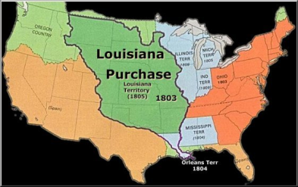
Election of 1800
Thomas Jefferson
Jefferson’s inaugural address
“midnight judges”
Louisiana Purchase (1803)
Justice Samuel Chase
Lewis and Clark Expedition (1804)
Hamilton-Burr Duel (Hamilton dies)
Pike Expedition (1805)
Berlin and Milan Decrees (1807)-made by Napoleon, tried to force European nations NOT to trade with Great Britain
Orders in Council
Impressment-forcing American sailors to join British ships
Chesapeake-Leopard Affair
Essex Case
Non-intercourse Act
Macon Bill #2-bill intended to motivate France and Britain to stop seizing American vessels during the Napoleonic wars
Tecumseh
War hawks
Causes of War of 1812
Federalist opposition to war
Treaty of Ghent (1814)-ended War of 1812
Jackson’s Victory at New Orleans (1815)

Nationalism and Sectionalism:
Tariff of 1816
Bonus bill veto
Rush-Bagot Agreement (1817)-Great Lakes
Panic of 1819
West Florida
Adams-Onis Treaty (1819)-U.S. gains Florida
Quadruple Alliance
Holy Alliance
Monroe Doctrine (1823)-warned European powers to stay out of Western hemisphere
Era of Good Feelings (1817-1824)
Marshall Court decisions (pro-federalist)
Missouri Compromise (1820)
Tallmadge Amendment (anti-slavery, was not included in the Missouri Compromise)
Clay’s American System (internal improvements such as road building, nat’l bank. tariffs)
Samuel Slater
Robert Fulton
Eli Whitney
Daniel Webster
John C. Calhoun
John Quincy Adams
“corrupt bargain” (election of 1824)
Panama Conference
Tariff of Abominations (1828)
South Carolina Exposition and Protest (SC would secede if Tariff of Abominations was not repealed-Calhoun (author) resigned in protest)
Nullification-idea that states could reject federal laws (i.e. tariffs)

Jacksonian Democracy, 1828 to 1840:
Jacksonian Revolution
Common man theory
Franchise (vote) expanded (to property holders)
Spoils system-giving jobs to campaign supporters
Caucus system
National nominating conventions
Kitchen cabinet-group Jackson met with regularly after he fired most of his cabinet
Cherokee Indian Removal
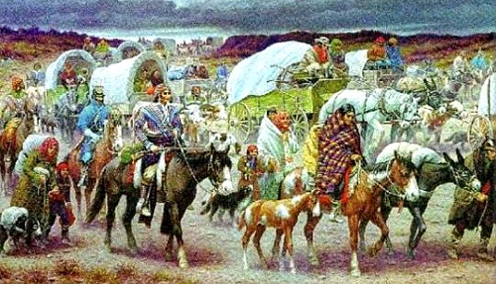

Trail of Tears (1830s)
Whigs
Maysville Road Veto
Anti-Masonic Party
Nicholas Biddle-president of 2nd B.U.S.
Bank Re-chartering (1832)
Webster-Hayne Debate (RE: tariffs)
Peggy Eaton Affair
Calhoun resigns vice-presidency
Clay: Compromise Tariff (1833)
Force Bill (enforce tariffs on states claiming nullification)
specie circular/Coinage Act (1836)-executive order by Jackson that government land had to be paid for in gold or silver
Panic of 1837
Independent Treasury Act
Pre-emption Act
Tariff of 1842
Roger B. Taney

Social, Education, Intellectual and Religious Reforms:
Transcendentalism
Ralph Waldo Emerson “self reliance”
Henry David Thoreau, On Walden Pond, “Essay on Civil Disobedience”
James Fenimore Cooper, Last of the Mohicans
Herman Melville, Moby Dick
Nathaniel Hawthorne, The Scarlet Letter
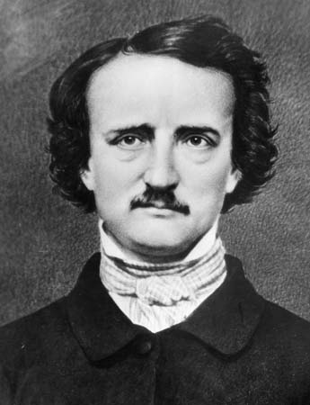
Edgar Allan Poe, “Tell Tale Heart”

Henry Wadsworth Longfellow
Margaret Fuller
Hudson River School of Art-landscape painters
Walt Whitman
Alexis de Tocqueville, Democracy in America- studied effects of social equality on democracy
Charles G. Finney (Second Great Awakening)
“burned over district”
lyceum movement
Mormons, Joseph Smith, Brigham Young, Utah
Brook Farm
Oneida Community
New Harmony
Shakers
Dorothea Dix (advocate for mentally ill)
Oberlin College
Rise of Labor Leaders
American Temperance Union
“Ten Nights in a Bar Room” (prohibitionist play)
Nativism
Irish/German immigration
Lucretia Mott (“first American feminist”)
Samuel B. Morse (morse code)
Seneca Falls Convention (1848)
Women’s Rights
“cult of domesticity”/Cult of True Womanhood
Emma Willard
Anti-Slavery movement (1830s)
Prison reform

UNIT FOUR: 1840-1877

Manifest Destiny:
“Manifest Destiny”
Horace Greely
Stephen Austin
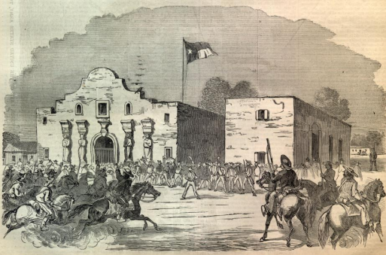
Jedediah Smith
Alamo
Santa Anna
Sam Houston
San Jacinto
Liberty Party
Republic of Texas
James K. Polk
“54-40 or FIGHT”-slogan to obtain NW land
Rio Grade river
John Slidell
General Zachary Taylor
Stephen Kearny
Mexican War: Causes and Results
Nicholas Trist
John C. Fremont
Mexican Cession
Treaty of Guadalupe Hidalgo-ended Mexican American War, territory gain for U.S. of present day CA, AZ, etc.
Caroline and Creole affairs
Webster-Ashburton Treaty
John Jacob Astor-first multi-millionaire
Aroostook War (1838)-undeclared war b/w Great Britain and U.S. over Maine/Canada border
Election of 1848: Cass v. Taylor
49th Parallel
Gadsden Purchase
Wilmot Proviso
Hegemony
Great Salt Lake/Brigham Young
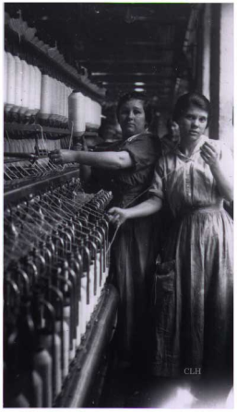
Economy:
“transportation revolution”
Erie Canal
National Road
Lowell Factory-“Lowell girls”
Cyrus McCormick/mechanical reaper
Elias Howe
Ten-hour movement
Clipper ships
Cyrus Field
Robert Fulton
Walker Tariff
Independent Treasury System
Martin Van Buren

The South and Slavery:
American Colonization Society (1816)-back to Africa
Eli Whitney-cotton gin (1793)-expanded slavery
Abolitionism
Sectionalism
William Lloyd Garrison, The Liberator
American Anti-Slavery Society
Grimke Sisters
Nat Turner, Denmark Vesey, Gabriel Prosser (slave rebellions or attempted slave rebellions)
Frederick Douglas
“King Cotton”
Know-Nothing Party
Free Soil Party

The Blundering Generation, 1850s:
John Sutter, “49’s”
Compromise of 1850, Fugitive Slave Law
Webster’s 7th of March Speech-defended the Fugitive Slave Law
Henry Clay
Harriet Tubman, underground railroad
Ostend Manifesto (plan to acquire Cuba-failed)
“peculiar institution”
Harriet Beecher Stowe, Uncle Tom’s Cabin
“Beecher’s Bibles”
Hinton R. Helper, Impending Crisis of the South
Election of 1852-Whigs
Stephen A. Douglas-popular sovereignty
“Bleeding Kansas”
Dred Scott decision (1857)
Sumner-Brooks Affair
LeCompton Constitution (ultimately rejected)
Lincoln-Douglas Debates (1858)
Freeport Doctrine (1858)
Harper’s Ferry/John Brown (1859)
Election of 1860 (John Bell, John Breckenridge)
Republican Party of 1860
Crittenden Compromise

Civil War and Reconstruction:
Border States
North’s advantages
South’s advantages
Fort Sumter
Bull Run
Lee, Jackson, Beauregard (Confederacy)
Grant, Meade, McClellan, Sherman (Union)
Monitor versus the Merrimac
Cotton vs. wheat
Bull Run
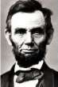
Jefferson Davis (President of the Confederacy)
Abraham Lincoln
Suspension of habeas corpus
Copperheads
Northern blockade
Conscription
Emancipation Proclamation (added moral element to the Civil War)
Conscription
Election of 1864
Scalawags and carpetbaggers
Wade-Davis Bill
Lincoln’s 10% plan
Thaddeus Stevens
Black codes
Charles Sumner
Andrew Johnson
Ku Klux Klan
Freedmen’s Bureau
Lincoln’s Assassination
13th Amendment
14th Amendment
15th Amendment
Tenure of Office Act
Impeachment
William H. Seward, purchase of Alaska (“Seward’s Folly”)
Treaty of Washington
Hamilton Fish (Grant’s Sec. of State)
Ulysses S. Grant
Compromise of 1877-put Hayes in presidency, in return for end of military Reconstruction
Hayes-Tilden Election (1876)
Sharecropping

UNIT FIVE: 1877-1900 (Gilded Age)

Politics:
Whiskey Ring
Waving the Bloody Shirt (reminding people who won the Civil war)
Liberal Republicans
Panic of 1873
Solid South
Ohio Idea
Greenback-Labor Party
Pendleton Civil Service Act
Chester A. Arthur
James A. Garfield
James G. Blaine
Grover Cleveland
Stalwarts
Half-breeds
Mugwumps
“Rum, Romanism and Rebellion”
Treasury surplus
Pensions, Grand Army of the Republic (GAR)
Secret (Australian) Ballot
Dingley Tariff

Business Developments and Personalities:
Laissez-faire
Adam Smith, The Wealth of Nations (capitalism)
Union Pacific Railroad
Central Pacific Railroad
Credit Mobilier
“robber barons”
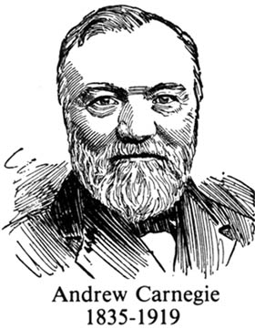
John D. Rockefeller
Andrew Carnegie
Horizontal integration
Vertical integration
Charles Schwab
Thomas A. Edison
Alexander Graham Bell
Leland Stanford
James J. Hill, Great Northern Railroad
Cornelius Vanderbilt
New York Central Railroad
Bessemer process
United States Steel Corporation
J. Pierpont Morgan
Gustavas Swift
Phillip Armour
James B. Duke (tobacco)
Andrew Mellon
“stock watering”
Jay Gould and Jim Fisk
pools
rebates
trusts
holding companies
interlocking directorates
mergers
14th Amendment-“Due Process”
Interstate Commerce Act
Sherman Anti-Trust Act (1890)

Labor Developments:
National Labor Union
William Sylvis
Knights of Labor
Terrence Powderly
American Federation of Labor, Samuel Gompers
collective bargaining
injunction
strikes
boycotts
yellow dog contracts
company unions
company towns
Great Railroad Strike of 1877
Haymarket Square Riot (1886)
Homestead Strike (1892)
Pinkertons
American Railway Union
Pullman Strike of 1894
Eugene V. Debs
Richard Olney

Urbanization: The Rise of the City:
George Washington Plunkett
“honest graft”
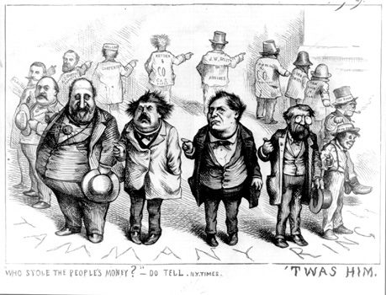
Boss Tweed
Tammany Hall (political machines)
Thomas Nast (cartoonist, helped bring down Tweed)
“new immigration”
tenements-low income housing
Jane Addams, Hull House
Denis Kerney
Chinese Exclusion Act (1882)
Literacy tests
American Protective Association
Frank Lloyd Wright (architect)
Louis Sullivan (architect) “father of the modern skyscraper”

Gilded Age: Social, Intellectual and Cultural Movements:
Charles Darwin (theory of evolution), On Origin of the Species
Herbert Spencer, Social Darwinism (applied to business)
Andrew Carnegie, The Gospel of Wealth
Henry Ward Beecher
Dwight L. Moody
Reverend Josiah Strong
Salvation Army
Social Gospel Movement
YMCA
Brigham Young
Morrill Act-funding education
Edward Bellamy, Looking Backward
Henry George, Progress and Poverty-book on inequality
Single tax
“Gilded Age”
noveau riche
Mark Twain
Stephen Crane
Henry James
Horatio Alger books
Willa Cather
Joseph Pulitzer
William Randolph Hearst
Susan B. Anthony, women’s rights
Elizabeth Cady Stanton, women’s rights
Alice Paul, women’s rights
Carrie Chapman Catt, women’s rights
Francis Willard, temperance, women’s rights
Carry A. Nation, temperance
Clara Barton, American Red Cross

African-Americans:
Mississippi Plan
“New South”-South after Civil War-idea they would become more industrialized and forge partnerships with the Northern economy
Henry Grady
Slaughter House Cases-tested 14th amendment
Sharecropping
Crop lien laws
Lynching
Booker T. Washington
George Washington Carver
W.E.B. Dubois
“talented tenth”
Jim Crow laws
Niagara Movement-led to NAACP founding
NAACP (founded 1909)
The Crisis (official magazine of NAACP)
The West and Populism:
Homestead Act of 1862
Oliver H. Kelly
Granger Movement
Granger Laws
Barbed wire
Plains Indians
Chivington/Sand Creek massacre (CO), 1864
Custer’s Massacre (a.k.a. Battle of Little Bighorn), Montana (1876)
Fetterman Massacre/Red Cloud’s War, Wyoming and Montana (1866-68)
Chief Joseph “I will fight no more forever”
Battle of Wounded Knee (1890)
Dawes Severalty Act (1887)
Safety valve thesis
Frederick Jackson Turner, Frontier Thesis
Comstock Lode
“Crime of ‘73”
Sherman Silver Purchase Act
Free silver
16:1 ratio (16 oz. of silver=1 oz. of gold)
Coxey’s Army
Farmer’s Alliance
Populist Party Platform, 1892
Mary Ellen Lease
William Jennings Bryan
“Cross of Gold” speech
Election of 1896

UNIT SIX: 1900-1920

Imperialism, Progressivism, and World War I:
James G. Blaine
Pan-Americanism
Venezuelan Boundary Dispute
Bering Sea Controversy
“yellow journalism”
de Lome letter-written by Spanish Ambassador that criticized President McKinley and fired up the American public to go to war with Spain
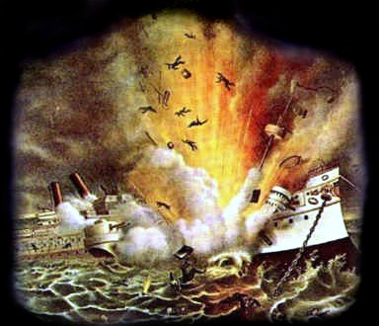
Maine explodes
Commodore Dewey
President Cleveland and Hawaii
Queen Liliuokalani-last monarch of Hawaii
Rough riders
San Juan Hill
Treaty of Paris, 1899
Philippines, Guam, Puerto Rico
Walter Reed
Teller Amendment-U.S. could not annex Cuba
Platt Amendment-U.S. withdrawal from Cuba
protectorate
spheres of influence
Open Door Notes (policy)
Philippine Insurrection
Boxer Rebellion (1900)
extraterritoriality
most favored nation status
Big Stick policy (T. Roosevelt)
Clayton-Bulwer Treaty (1850)
Hay-Pauncefort Treaty
Hay-Herran Treaty
Hay-Banau-Varilla Treaty
Panama revolution
Panama Canal
Venezuelan Crisis
Roosevelt Corollary
Dominican Republic
Russo-Japanese War
Treaty of Portsmouth
San Francisco School Board Incident
Gentlemen’s Agreement
Great White Fleet
Root-Takahira Agreement
Lansing-Ishii Agreement (1917)
Progressivism: The Age of Reform:
Democracy, efficiency, and pragmatism
“muckrakers”-journalists that wrote to expose problems in society to the public
Jacob Riis, How the Other Half Lives
Lincoln Steffens, The Shame of the Cities
Frank Norris, The Octopus
Ida Tarbell, The History of Standard Oil Company
Upton Sinclair, The Jungle
John Spargo, The Bitter Cry for the Children
Charlotte Gilman Perkins, Woman and Economics
John Dewey, The School and Society
Oliver Wendell Holmes
Margaret Sanger-birth control (1920s)
“Fighting Bob” LaFollette
Direct primary, Initiative, referendum, recall (political progressivism)
16th Amendment-income tax
17th Amendment-direct election of senators
18th Amendment-Prohibition (no alcohol)
19th Amendment-women’s suffrage
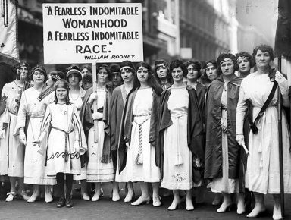
Charles Evans Hughes
WCTU
Anti-Saloon League
Square Deal, 3 C’s (TR)
Newland Reclamation Act
Anthracite Coal Strike of 1902
Forest Reserve Act
Elkins Act (1903)-imposed fines on railroads offering rebates
Hepburn Act (1906)-gave ICC power to regulate railroad rates
Trustbusters
Northern Securities Case
Meat Inspection Act (1906)
Pure Food and Drug Act (1906)
Conservation Act, 1908
Election of 1908
Mark Hanna
scientific management
Florence Kelley-fought for child labor laws and better working conditions for workers
regulatory commissions
Department of Labor established
Payne-Aldrich Tariff
Department of Commerce established
Ballinger-Pinchot controversy
“Dollar Diplomacy” (Taft)
Taft-Roosevelt Split
Bull Moose Party
Teddy Roosevelt’s “New Nationalism”
The Promise of American Life
Daniel DeLeon, IWW, “Big Bill”
Herbert Croly
arbitration of disputes
Federal Trade Commission
Louis Brandeis, “Brandeis Brief”
Adamson Act
Jones Act, Philippines
Jones Act, Puerto Rico
Mexican Revolution
Pancho Villa and General Pershing
ABC Powers

The First World War Era: 1912-1920:
sickman of Europe (Ottoman Empire)
Triple Alliance
Triple Entente
British blockade
loans to the Allies
Election of 1916
Lusitania, Sussex Pledge
Zimmerman note (telegram to Mexico from Germany, intercepted by British)
unrestricted submarine warfare
War Declared by U.S. on Germany, April 1917
Russian Revolution, 1917
Woodrow Wilson, “make the world safe for democracy”
Creel Committee (propaganda)
Bernard Baruch
Eugene V. Debs imprisoned
Herbert Hoover
selective service
War Industries Board
Rationing: “meatless Mondays”, “wheatless Wednesdays”
total war
Versailles Peace Conference
Self-determination
new nations
reparations (war payments)
Article 10-members of League of Nations will help each other if attacked
Article 231-full blame on Germany
Senate rejection of treaty
Strikes: Steel, Coal, Police
Irreconcilables: Borah, Johnson, Smoot, Lodge
Depression of 1920

UNIT SEVEN: 1920-1940

The 1920s:
“normalcy”
Esch-Cummins Transportation Act (1920)- returned railroads back to private ownership after WWI with much regulation.
Harding Scandals
Death of Harding
Secretary Mellon, tax cuts
“The Business of America is Business”-Coolidge
Senator Norris, Muscle Shoals
McNary-Hagen Bill (1924)-vetoed twice by Coolidge (never passed), this bill aimed at helping farmers by raising ag prices
Bruce Barton, The Man Nobody Knows
H.L. Menken, American Mercury magazine
“Lost Generation”: Gertrude Stein, Ernest Hemingway, T.S. Eliot, F.S. Fitzgerald, Sinclair Lewis.
Sigmund Freud, psychoanalysis
Prohibition, 18th Amendment, Volstead Act
KKK
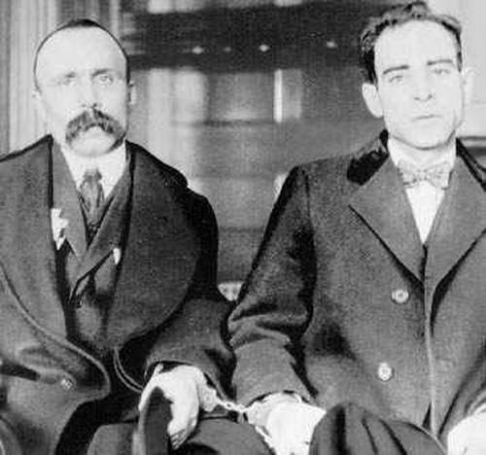
Gangsters, bootlegging, Al “Scarface” Capone
Sacco and Vanzetti Case
Leopold and Loeb Case
Scopes Trial, a.k.a. “Monkey Trial”
Billy Sunday
Henry Ford, Model T, moving assembly line
Cecil B. DeMille
The Jazz Singer (1927), first sound movie
Rudolph Valentino
Charlie Chaplin
“new woman,” flappers
Charleston dance
Harlem Renaissance
Langston Hughes
Marcus Garvey, Back to Africa movement
Charles Lindberg, Spirit of St. Louis plane
Babe Ruth (baseball)
Jack Dempsey (boxing)
Election of 1920

Foreign Policy:
Washington Naval Disarmament Conference: Four Power Pact, Five Power Pact, Nine Power Pact
World Court
Dawes Plan
Kellogg-Briand Pact (1928)-outlawing war
Rise of Fascism

Hoover and the Depression:
Causes of Depression
Ford-McCumber Tariff
Hawley-Smoot Tariff (1930)-high tariff, deepened international economic depression
Reconstruction Finance Corporation (RFC)
“Hoovervilles”
Bonus Army
London Naval Conference
Hoover-Stimson Doctrine
Norris-LaGuardia Act (1932)
Good Neighbor Policy
Election of 1932

Franklin D. Roosevelt and the New Deal Years:
20th Amendment-moves up date of inauguration to January 20th (shortens lame duck period)
21st Amendment-repeals Prohibition
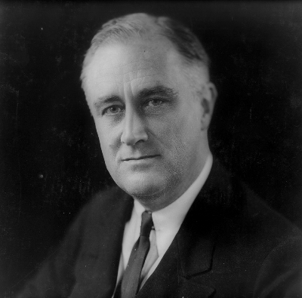
“Bank Holiday”
Hundred Days
3 R’s: Relief, Recovery, Reform
Brain Trust
Emergency Banking Relief Act
Glass-Steagall Act (Bank Reform of 1933)- established the Federal Deposit Insurance Corporation (FDIC)
Gold Clause Act
National Industrial Recovery Act
Agricultural Adjustment Act
Soil Conservation Act (1936)
Civilian Conservation Corp
Public Works Administration
Works Project Administration
Federal Housing Authority
Securities and Exchange Commission
Tennessee Valley Authority
Rural Electrification Administration
National Youth Authority
Indian Reorganization Act (“Indian New Deal”)
Wagner Act (“Magna Carta” of Labor)
Congress of Industrial Organization (CIO)
John L. Lewis
Francis Perkins, Secretary of Labor (also, first woman in the cabinet)
deficit spending
“court packing” proposal
Social Security Act
Liberty League
Chief Justice Charles Evans Hughes
Miller-Tydings Act (1937)
Democratic coalition: blacks, unions, Southern intellectuals, and Big City machines
Dr. Francis Townshend
Hatch Act
Father Charles Coughlin

UNIT EIGHT: 1940-1960

Tydings-McDuffie Act
Buenos Aires Conference
Nye Committee-studied America’s involvement in WWI (amid charges munitions manufacturers promoted U.S. entrance into WWI)
Benito Mussolini
Quarantine Speech
“Panay” incident
Hitler, Nazism
Munich Conference, appeasement, Neville Chamberlin
Axis Powers (Germany-Italy-Japan)
Blitzkrieg
Invasion of Poland, Sept. 1, 1939 (WWII begins)
“cash and carry” policy
Fall of France
Isolationism, America First Committee, Charles Lindberg
Smith Act (1940)-makes it a criminal offense to plot against the government
General Tojo (Japan)
destroyer deal, Lend-Lease Act (1941)
Election of 1940
Atlantic Charter, August 1941
Pearl Harbor, December 7, 1941
Navajo codetalkers
Tuskegee Airmen (African American pilots)
Women during WWII
442nd Regiment (Japanese American unit)
Japanese Internment
Korematsu v. United States
War Labor Board
Office of Price Stabilization
General Dwight D. Eisenhower, D-Day (6-6-44)
Battle of Stalingrad (turning point in Europe)
Battle of Midway (turning point in Pacific)
Winston Churchill
Casablanca Conference
Teheran Conference
“unconditional surrender”
Okinawa, Iwo Jima
Battle of the Bulge (last German offensive)
Manhattan Project, J. Robert Oppenheimer
Atomic Bomb, Hiroshima and Nagasaki
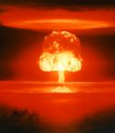

Cold War Years:
Yalta Conference (Feb. 1945)
Potsdam Conference (July 1945)
Partitioning: Germany, Korea, Vietnam
Charles de Gaulle
Bretton Woods Conference
Iron Curtain Speech (Churchill)
San Francisco Conference
United Nations Charter
Atomic Energy Conference
socialism
communism
superpowers
satellites
Nuremberg War Trials
Department of Defense created
George F. Kennan-containment theory
Truman Doctrine, first used in Greece and Turkey ($400 million in aid)
Marshall Plan
Point Four Program
Israel created, 1948
NATO
SEATO
CENTO
collective security
Fall of China (1949), Mao Zedong
Korean War (1950-53)
Truman-Macarthur Controversy
Gandhi, non-violent protest
John Foster Dulles, “policy of boldness”
“massive retaliation”
brinkmanship
preemptive strike
Khrushchev, Geneva Summit
Hungarian Revolt, 1956
Organization of American States
Nasser, Suez Canal
Eisenhower Doctrine
Fidel Castro’s Revolution
Domestic Affairs of the 1940s and 1950s:
G.I. Bill of Rights
postwar inflation
Baby Boom
suburbs
“white flight”
Employment Act of 1946
Taft Hartley Act (1947)
“right-to-work” laws
Election of 1948
Dixiecrats: J.Strom Thurmond
McCarthyism
House Un-American Activities Commission
Julius and Ethel Rosenberg
Alger Hiss
Army-McCarthy hearings
Whittaker Chambers, Pumpkin Papers, Nixon
22nd Amendment-term limits on president (2), passed 1947
Ike and Modern Republicanism
Federal Interstate Highway Act (1956)
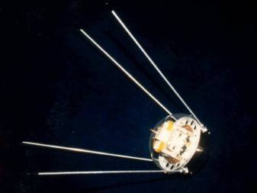
Jimmy Hoffa
Sputnik (1957)
NASA (1958)
AFL-CIO merger
“military industrial complex”

Civil Rights, 1940s and 1950s:
desegregation of military (1948)
Jackie Robinson breaks MLB color line
Double V campaign (WWII)
CORE (Congress on Racial Equality), James Farmer
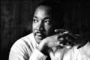
Brown v. Board of Education (1954)
Rosa Parks
Montgomery Bus Boycott
Martin Luther King, Jr.
NAACP
Little Rock Nine, Central High School (1957)
George Wallace, “segregation today, segregation tomorrow, segregation forever!”

UNIT NINE: 1960 to Present

Civil Rights, 1960s:
Sit-in movement
SNCC (Student Non-Violent Coordinating Committee)-Stokley Carmichael
Freedom Riders
Freedom Summer
Birmingham, Alabama
Children’s Marches
16th Street Church Bombing
MLK, Jr: Letters from a Birmingham Jail- advocated non-violent resistance
March on Washington, I have a Dream speech
Civil Rights Act of 1964
Voting Rights Act of 1965
24th Amendment-abolish poll tax (1964)
Malcolm X (assassinated 1965)
Black Power
Black Pride
Black Panther Movement (Oakland, CA)
Assassination of Dr. King (1968) in Memphis
“New Frontier” (JFK)
Election of 1960, electronic media
Camelot
Bay of Pigs Invasion
Alliance for Progress
Peace Corps
Cuban Missile Crisis
Assassination of JFK by Lee Harvey Oswald, Nov. 22, 1963
The Feminine Mystique, Betty Friedan
Origins of feminist movement
Assassination of Bobby Kennedy (1968)
Great Society/War on Poverty (LBJ)
Vietnam War-Gulf of Tonkin Resolution (1964), Tet Offensive (1968)
counterculture movement/hippies
Pentagon Papers
détente
Vietnamization
Fall of Saigon, 1975
Cambodia bombings
Kent State (1970)
War Powers Act (1973)
“I’m not a crook” (Nixon),Watergate scandal, Nixon resigns, Ford pardons Nixon
Camp David Accords
Iran Hostage Crisis
boycott of 1980 Olympics in Moscow
HIV/AIDS crisis (1980s)
Iran-Contra Affair
Sandra Day O’Connor
Geraldine Fierro (first woman on a P/VP ticket)
supply-side economics (Reaganomics), trickle- down theory
Space Shuttle Disaster
Gulf War (1991)/Operation Desert Storm
Saddam Hussein
“Read my lips, No New Taxes!” (Bush, Sr.)
NAFTA (1994)
Monica Lewinsky and Whitewater scandals
Newt Gingrich’s “Contract with America”
Quizzes Available on:
www.historyteacher.net

